C#

1. Features of C#
   1. Object oriented.
   2. Platform Independent – Windows, IOS, Android.
   3. Language Independent (Cross Language Reusability) – VC++.NET, VC#.NET & VB.NET – MSIL.
2. Constructors –
   1. It is a special method present under a class responsible for initializing the variable of that class.
   2. Constructors are non-value returning method.
   3. Each and every class requires constructor if you want to create the instance of the class.

class Test

{

int I; string b; bool c;

}

Test a = new Test(); //valid

* 1. It’s responsibility of a programmer to define a constructor under his class and if he fails to do so, on behalf of the programmer an **implicit constructor** gets defined in the class by complier.

class Test

{

int I; string b; bool c;

Public Test() //Complier defined the constructor -

{

int I = 0; string b = “45”; bool c = false; //Initializing the variable

}

}

Test a = new Test(); //valid

* 1. Implicitly defined constructors are parameter less and these constructors are also known as default constructors.
  2. Implicitly defined constructors are public.
  3. Explicit constructors are defined by programmers. Explicit constructor can be parameter less or parameterized.

[<modifiers>] <Name>( [<Parameter List>] )

{

//-statements.

}

**Defining the constructor:** Implicit or Explicit

**Calling the constructor:** Explicit

1. Types of Constructor
   1. Default or Parameter less constructor
      1. If a constructor method doesn’t take any parameters then we call that as default or parameter less constructor.
      2. These constructors are defined by programmers explicitly or else will be defined by complier if there is no explicit constructor under the class.
   2. Parameterized Constructor
      1. If a constructor method is defined with parameters we call that as parameterized constructor.
      2. These constructors can only be defined by programmer explicitly.
   3. Copy Constructor
      1. If you want to create multiple instances with the same value then we use copy constructor.
      2. In copy constructor, constructor takes the same class as parameter to it.

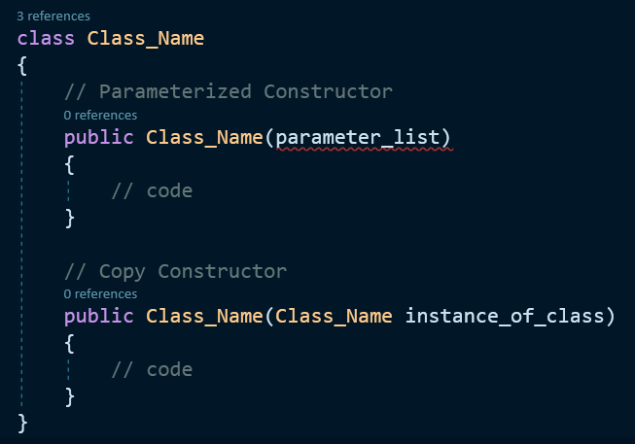

* 1. Static Constructor:
     1. If a constructor is explicitly declared by using static modifier we call that as static constructor.
     2. All the constructor we have defined till now are non-static or instance constructor.

[<Static Modifier>] [<Constructor Name>](){}

* + 1. If a class contains any static variables then only implicit static constructor will be present or else we need to define explicitly.
    2. Whereas non-static constructors will be implicitly defined in every class (except static class) provided we did not define them explicitly.
    3. Static constructor are responsible in initializing static variables.
    4. Static constructors are never called explicitly they are implicitly called.
    5. Static constructors are first to execute under any class.
    6. Static constructors can’t be parameterized so overloading static constructors is not possible.
    7. **Defining the static constructor:** Implicit or Explicit
    8. **Calling the static constructor:** Implicit

1. Why constructors are needed?
   1. Every class requires a constructor to be present in it, if we want to create the instances of that class.
   2. Every class contains an implicit constructor if not defined explicitly and with the help of that implicit constructor the instance of the class can be created.
   3. What is the need of defining a constructor explicitly again?
      1. Implicit constructor of a class will initialize variables of a class with same value even if we create multiple instances of that class.
      2. If we define a constructor explicitly with parameters then we get a changes of initializing the fields or variables of the class with a new value every time we are creating instance of that class.

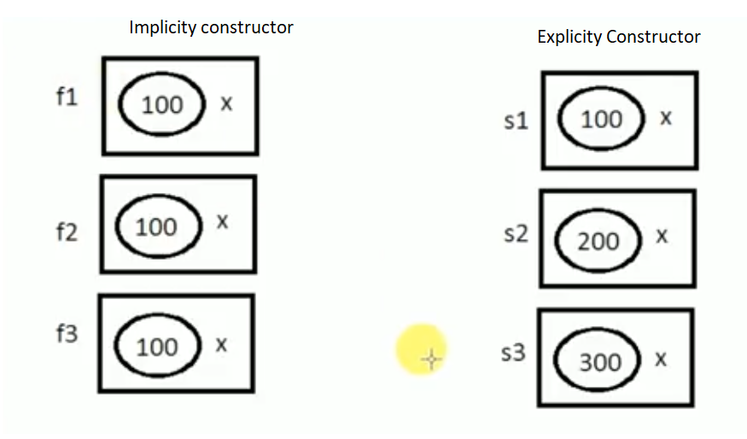

Note: Generally every class requires some value for execution and that values can be pass via constructors.

1. Static Constructor Vs Non-Static Constructors
   1. If a constructors is explicitly declared by using static modifier we call that constructors as static constructors whereas rest of others are non-static constructors only.
   2. Static fields/variables are initialized by static constructors.
   3. Non-static fields/variables are initialized by non-static constructors.
   4. Calling
      1. Static Constructors -> implicitly called.
      2. Non-Static Constructors -> explicitly called.
   5. Execution
      1. Static Constructors ->
         1. Executes immediately once the execution of the class starts
         2. It is the first block of code to run under the class.
      2. Non-Static Constructors ->
         1. It executes only after creating the instances of the class is created.
   6. Life Cycles
      1. Static Constructors
         1. Executes one and only one time
      2. Non-Static Constructors
         1. Executes zero time if no instances is created.
         2. “N” times if “N” instances are created.
   7. Non-Static Constructors can parameterized but static constructors can’t have any parameters because static constructors are implicitly called.
   8. Non-Static constructors can be overloaded whereas static constructors can’t be overloaded.
   9. Every class contains an implicit constructor if not defined explicitly and those implicit constructors are defined based on the following criteria
      1. Every class expect static class contains an implicit non-static constructors if not defined with an explicit constructor.
      2. Static constructors are implicitly defined only if that class contains any static fields/variables or else that constructors will not be present at all.

**Class**

1. Class – It’s a user-defined data type. It is blueprint or a plan. Class are collection of members.
2. Object – It is execution of the blueprint i.e. class.
3. Variable of class
   1. Copy of the class that is not initialized.

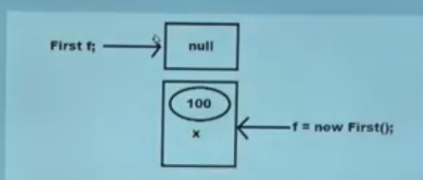

1. Instance of a class
   1. A copy of the class that is initialized by using new keyword which has its own memory and never shared with another instances.

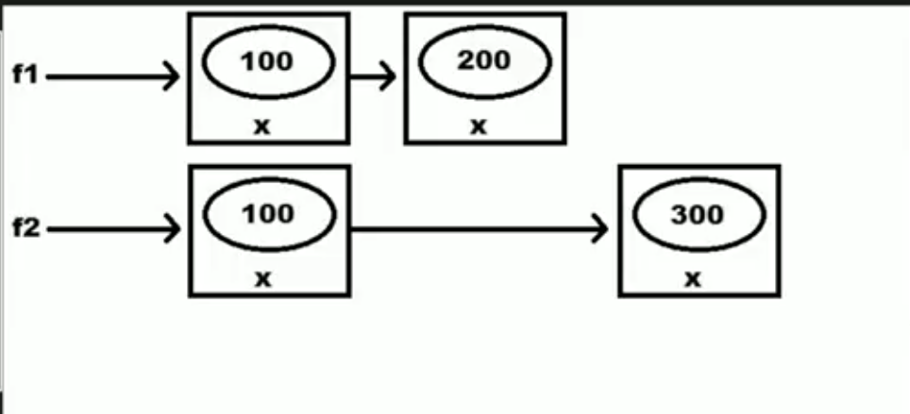

1. Reference of a class
   1. A copy of the class that is initialized by using an existing instances and references of class will not have any memory allocation.
   2. They will be sharing the same memory of the instance that was assigned for initializing the variable.
   3. Reference of a class can be called as pointer to the instance.
   4. Every modification we perform on the members using instance reflects when we access those members through references and vise-verse.

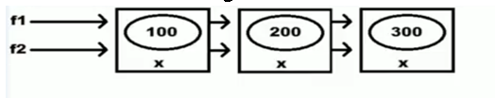

**Access Specifier**

1. It’s a special kind of modifiers using which we can define the scope of a type and its members.
2. Private: within the class.
   1. The private method is accessible only within the class in which it was defined.
   2. We cannot define Types as private i.e. user define types or types.
      1. Private class T {} – Not allowed.
   3. Default scope of all members under the class is private.
3. Internal: within the project, both child and non-child class.
4. Protected: within the same class and within the child class.
5. Protected Internal: Either within the project or within the child class of other/different project.
6. Public: Global Access.
7. The below table of understanding the scope of access specifier

|  |  |  |  |  |  |
| --- | --- | --- | --- | --- | --- |
| **Cases** | **Private** | **Internal** | **Protected** | **Protected Internal** | **Public** |
| **Consuming** Members of a class from **same** class | Yes | Yes | Yes | Yes | Yes |
| **Consuming** Members of a class from **Child** class of **same** project(**Inheritance**) | No | Yes | Yes | Yes | Yes |
| **Consuming** Members of a class from **non-Child** class of **same** project(Instance) | No | Yes | No | Yes | Yes |
| **Consuming** Members of a class from **Child** class of **another** project(**Inheritance**) | No | No | Yes | Yes | Yes |
| **Consuming** Members of a class from **non-Child** class of **another** project(Instance) | No | No | No | No | Yes |

Note:

* Private, Protected, Protected internal cannot be used to define/declare a class.
* Default access specifier of class is internal, if not mentioned/specified.
* Default scope of all members under the class is private, if not mentioned/specified.
* **On Member** of the **class** we can apply **5 Scopes** but for **Types** we can apply only **2 Scopes**

**(public & internal)**.

**Variables**

1. **Non-Static/Instance** Variable and **Static** Variables
   1. If a variables is explicit declared by using the static modifier or else if a variable is declared inside a static method then those variables are static and rest of the other are non-static.
   2. Static members of a class doesn’t require the instance of class for initialization or execution also, where as non-static member of a class requires the instance of class both for initialization and execution.
   3. Static variables of a class are initialized immediately once the execution of a class starts whereas instance variables are initialized only after creating the class instance.
   4. In the life cycle of a class a static variable is initialized one and only once whereas instance variables are initialized for “0” times if no instance is created and “n” times if “n” instances are created.

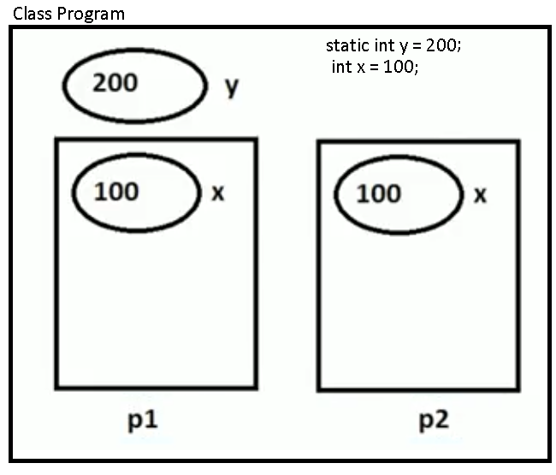

* 1. Initialization of instance variable is associated with instance creation and constructor calling, so instance variables can be initialized through the constructor also.

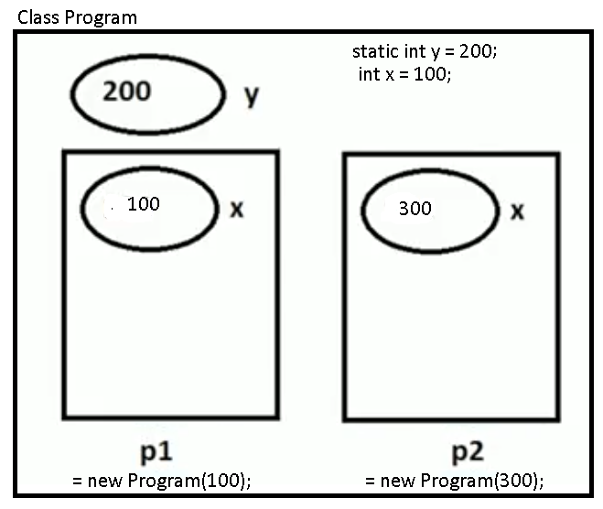

1. Constant Variable –
   1. If a variable is declared using **const** keyword we call it as constant variables.
   2. Constant variables can’t be modified once after there are declared.
   3. Constant variables must be declared and initialized at the same time.
   4. The behavior of constant variable is similar as of static variable with only one difference
      1. Static variables can be modified but constant variables cannot be modified.
   5. Constant variables are also initialized one and only one time in the life cycle of a class.
   6. Constant variables doesn’t require instance of class for accessing or initializing.

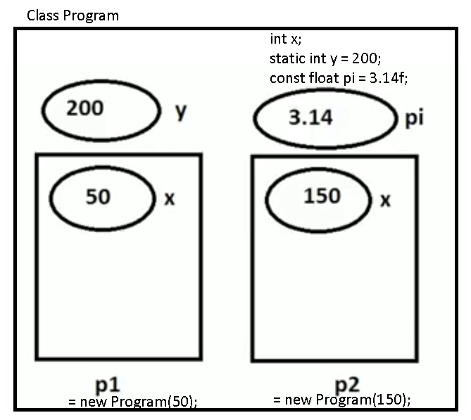

1. Read-only
   1. If a variable is declared using **readonly** keyword we call it as read-only variables.
   2. Read-only variables can’t be modified like constant variables but after initialization.
   3. It is compulsory to initialize the read-only variables at the time of declaration, they can also be initialized under the constructor.
   4. The behavior of read-only variables are similar to instance variables
      1. Initialized only after creating the instance of a class.
      2. Each instance of a class has a separate copy of read-only variable.
   5. The only difference between read-only variables and instance variable is
      1. Instance variable can be modified after instance of a class is created but read-only variables cannot be modified after instance of a class is created.

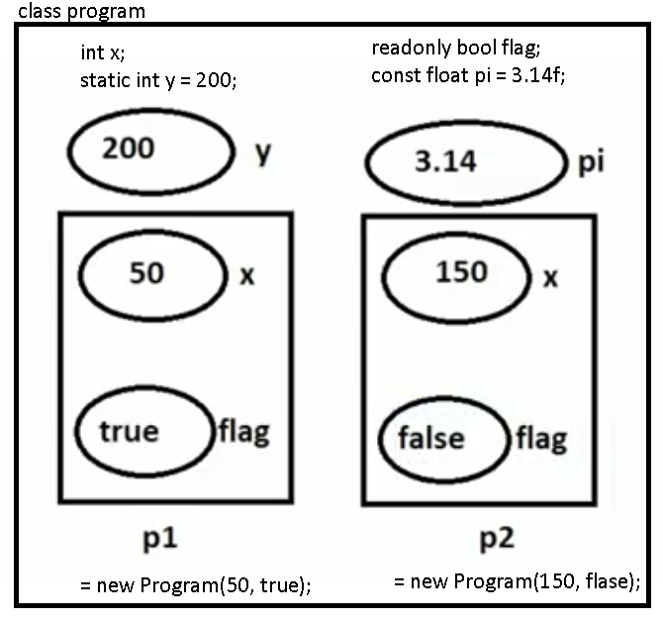

1. Constant Vs Readonly
   1. Constant variable is fixed value for the whole class.
   2. Readonly variables are fixed value for the specific instance of a class.

Note:

1. Single copy and modifiable - Static variables.
2. Multiple copy and modifiable – Non-Static/Instance variables.
3. Single copy and non-modifiable – Constant variables.
4. Multiple copy and non-modifiable – Read-only variables.

**Inheritance** – Re-usability

1. It’s a mechanism of consuming the members of one class in another class by establishing **parent/child** relationship between the classes which provides re-usability.

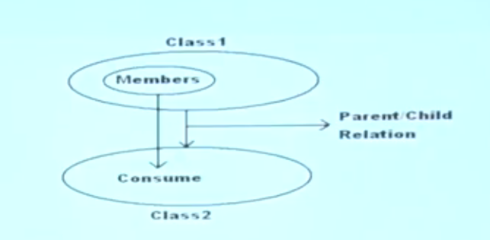

1. How to inherit a class:

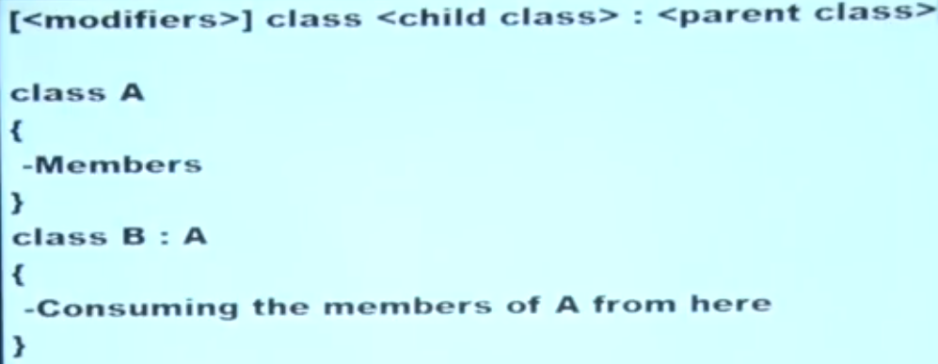

1. Terminology
   1. Class A – Base or Parent or Super class
   2. Class B – Derived or Child or Sub class
2. In inheritance, child class can consume member of the parent class as if it is the owner of those members expect **private members of parent class**.

**Important rules to remember while working with inheritance**

1. Parent class constructor should be accessible to child class, otherwise inheritance will not be possible.
   1. If you call the parent class constructor than only the parent class variables/members will be initialized and they can be consumed under the child class.
   2. Child class constructor implicitly calls the Parent class constructor.
2. In inheritance, child class can access parent class’s members but parent classes can never access any member that is purely defined under the child class.
3. We can initialize a parent class’s variable by using the child class instance to make it as reference, So that the reference will be consuming the memory of child class instance, but in this case also we can’t call any pure child class members by using the reference

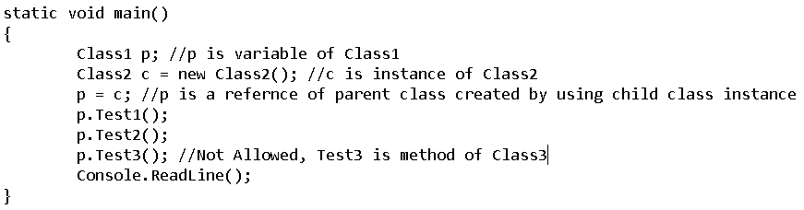

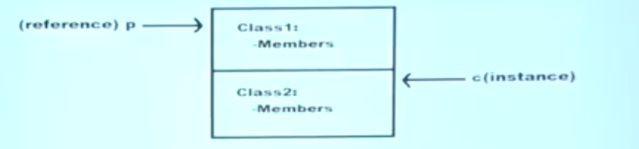

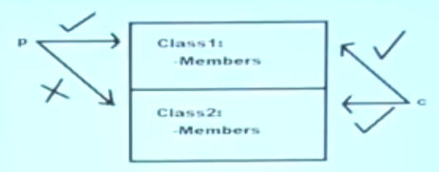

1. Every class that is defined by us or pre-defined in the libraries of the language has a **default parent class** i.e. **Object** class of **system** namespace.
   1. Members of the object class are accessible from anywhere.
   2. Members of the object class are **Equals(), GetHashCode(), GetType() and ToString().**
   3. **Object** class is the ultimate base class.

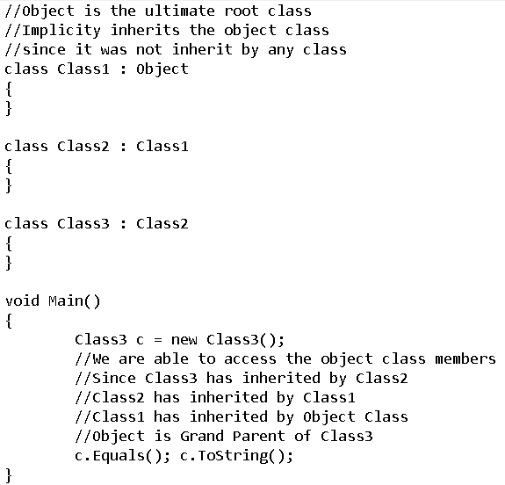

1. In CSharp, we don’t have support for multiple inheritance through classes, what we are provided is only single inheritance through classes.
2. If parent class constructor is parameterized and default constructor is not defined than child class cannot call the parent class constructor implicitly. So to overcome the problem, programmer should explicitly call parent class constructor from child class and pass values to those parameters.
   1. To call parent class constructor from child class, **base** keyword is used.

Eg. 1)

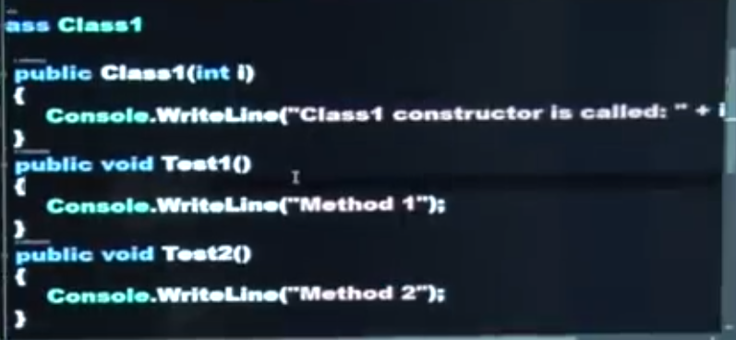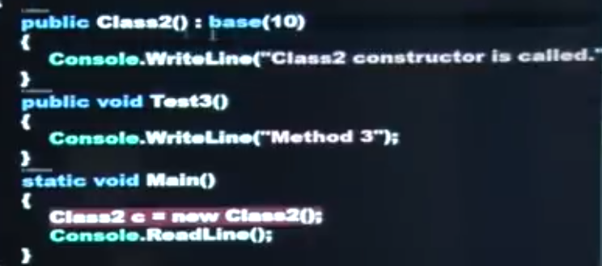

E.g. 2)

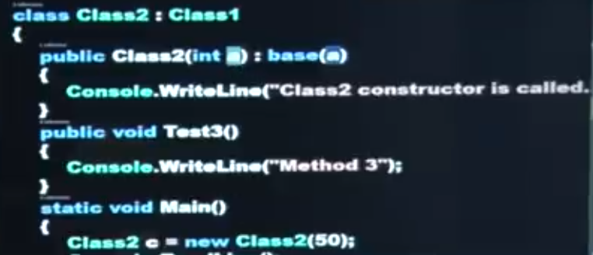

**Types of Inheritance**

1. No. of parent classes a child have or the no. of child classes a parent class have

|  |  |  |  |  |
| --- | --- | --- | --- | --- |
| Single | Multi-Level | Hierarchical | Hybrid | Multiple |
|  |  |  |  |  |

1. If at all a class has 1 immediate parent class to it we call it as **Single** inheritance and if it has more than one immediate parent class to it we call it **multiple** inheritance.

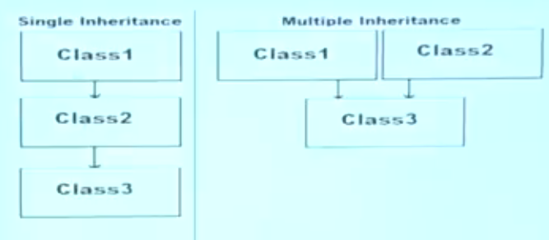

**How to use inheritance**

Entity – it is living or non-living object associated with set of attributes.

1. Identify the entities that are associated with the application we are developing.
   1. E.g. School Application: Student, Teaching Staff & Non- Teaching Staff.
2. Identify the attributes of each and every entities

|  |  |  |
| --- | --- | --- |
| Student | Teaching Staff | Non-Teaching Staff |
| Id  Name  Address  Phone  Class  Marks  Grade  Fees | Id  Name  Address  Phone  Designation  Salary  Qualification  Subject | Id  Name  Address  Phone  Designation  Salary  Dname  MgrId |

1. Identify the common attributes of each entity and put them in a hierarchical order

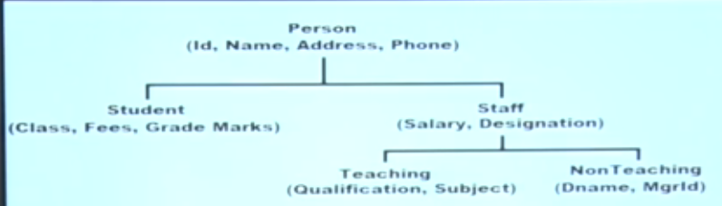

1. Define the class representing the entities that are put in hierarchical order

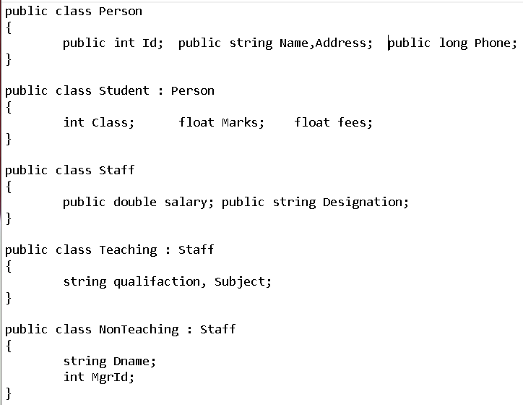

**Polymorphism** - **Method Overloading**

1. Method overloading is approach of defining method with multiple behaviors where behavior of the method will be changing based on the parameters of that method.

i.e. input changes -output changes

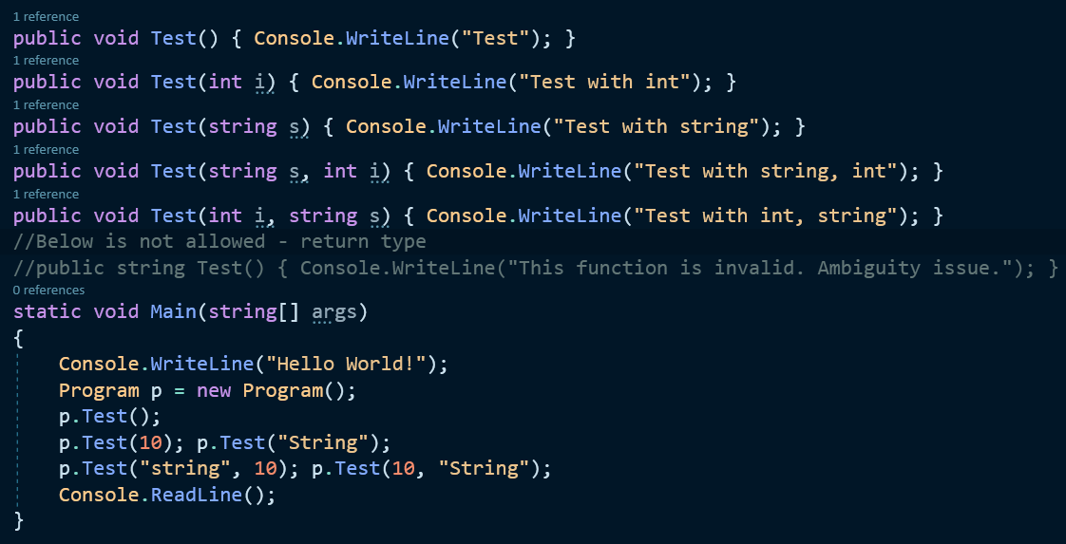

1. Why **return** types are not considered? – Compile time error – Ambiguity issue

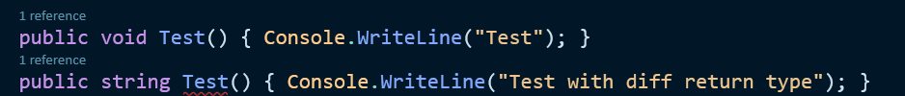

* 1. It causes ambiguity between the methods.
  2. Complier won’t be able to figure out which method to call, return type comes into picture at the end of execution but Calling of the method comes into picture at the start and if complier doesn’t knw where to start it will give you error “Ambiguity method”

1. Rules of Method overloading
   1. Number of parameters(inputs)
   2. Type of parameters(inputs)
   3. Order of parameters(inputs)
   4. Return Types are not taken into consideration.

**Polymorphism** - **Method Overriding**

1. Method overriding is an approach of re-implementing a parent class method under the child class with same signature.

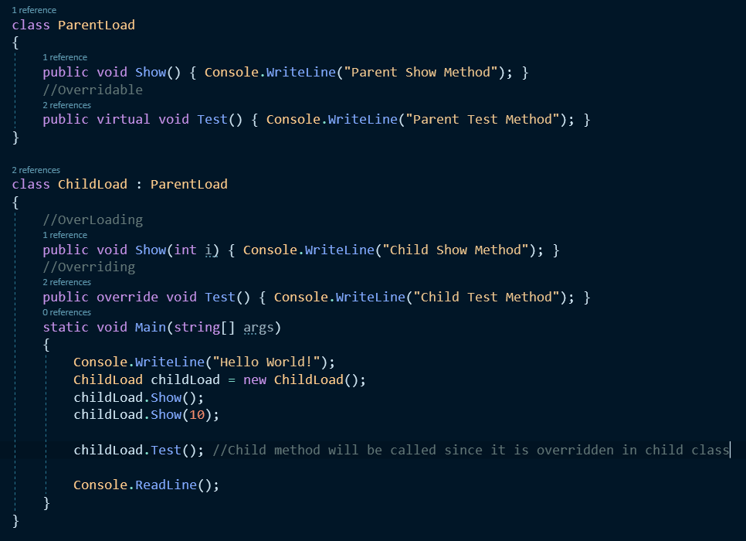

1. Difference

|  |  |
| --- | --- |
| Method Overloading | Method Overriding |
| 1. In this case, we define multiple methods with same name by changing their parameters. 2. This can be performed either within a class as well as between parent child classes also. 3. While overloading a parent class method under the child class, child class doesn’t require to take any permission from the parent class. 4. Overloading is all about **defining multiple behaviors** to a method. | 1. In this case, we define multiple methods with same name and same parameters. 2. This can be performed only between parent child classes it can never be performed within the same class. 3. While overriding a parent class method under child class required a permission from the parent class.   i.e. **virtual** keyword is required in the parent class method  public virtual void Test() {}   1. Overriding is all about **changing the behavior** of **parent class** under **child class.** |

1. If we want to override a parent method under child class first that method should be declared by using “**virtual**” modifier in parent class.
2. Any **virtual** method of the parent class can be overridden by the child class if required by using “**override**” modifier in child class.

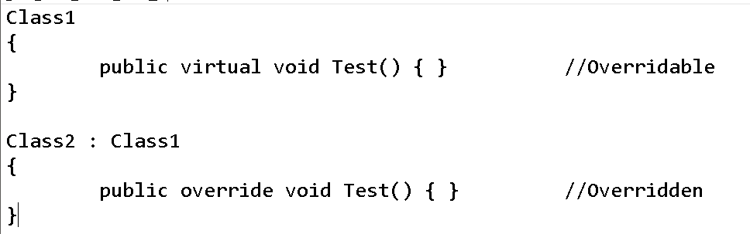

**Polymorphism** - **Method Hiding/Shadowing**

1. Differ & Commons

|  |  |
| --- | --- |
| Method overriding | Method hiding\shadowing |
| 1. Approach of re-implementing a parent classes method under the child class exactly with the same name and signature. 2. Child class **re-implements** its parent class methods which are **declared** as **virtual** 3. With permission – virtual –override keywords 4. In overriding, a parent class reference can call child classes overridden members. | 1. Approach of re-implementing a parent classes method under the child class exactly with the same name and signature. 2. Child class **re-implements** any parent class method even if it is **not declared** as **virtual**. 3. Without permission – new keywords. 4. In hiding, a parent class reference cannot call child class’s members which are re-implemented by hiding approach i.e. **new** keyword. |

1. We re-implement a parent classes method under the child class using 2 approaches
   1. Method overriding - **With permission – virtual – override keywords**
   2. Method hiding/shadowing – **Without permission – new keyword**
2. After re-implementing parent classes methods under child classes
   1. The child class instance will start calling the local methods (re-implemented methods) only.
   2. If required in any case, we can also call parent class method from child classes by 2 approaches
      1. By **Creating instance** of the parent class under the child class
      2. By using “**base**” keyword, we can calls parent class method.
         1. “**base**” & “**this**” keyword cannot be called inside **static** block.
3. A parent class reference even if created by using child class instance can’t access any members that are **purely defined** under the child class but can call **overridden** members of the child class.
   1. **Overridden** members are **not** considered as **pure child class** members.
4. Members which are **re-implemented** by using **method hiding** are considered as **pure child class** members hence are **not** **accessible** to **parent’s** **references**.

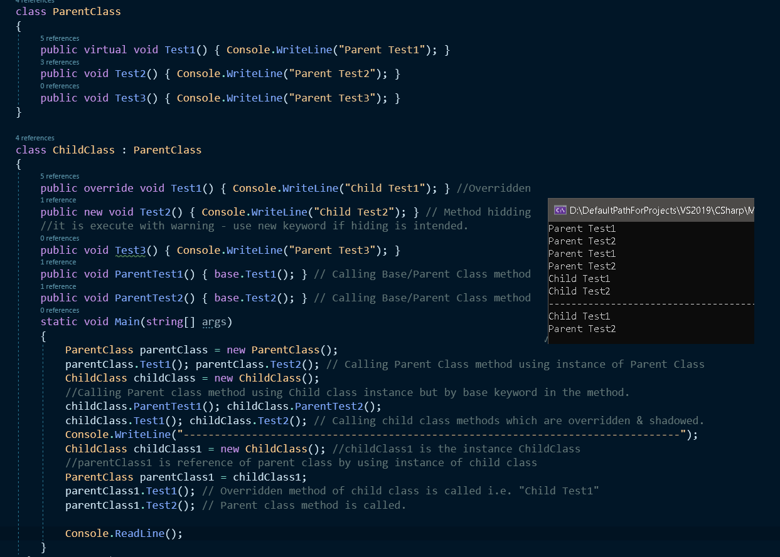

**Polymorphism** – **Operator Overloading**

1. **Method Overloading** is an approach of **defining multiple behaviors** to a **method** and those **behaviors** will **vary** based on the **input parameters** to that **method**.

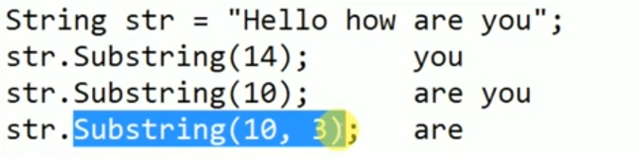

1. **Operator Overloading** is an approach of **defining multiple behaviors** to an **operator** and those **behaviors** will **vary** based on the **operand types between** which the **operator** is **used**.

**E.g.**

* + is an **addition** operator when used **between** 2 **numeric** **operands**
* + is an **concatenation** operator when used **between** 2 **string** **operands** 
  1. Number + Number => Addition
  2. String + String => concatenation

1. In the libraries of the language, operator +, - , * , / functionality is pre-defined as operator method.
   1. public static int operator +(int a, int b) 🡪 int z = 10 + 20;
   2. public static int operator –(int a, int b) 🡪 int z = 10 -20;
   3. public static string operator +(string a, string b)

string s1 = “Hello”; string s2 = “world”;

string s3 = s1 + s2;

* 1. public static bool operator >(int a, int b)

int a = 10; int b = 20;

bool b = a > b;

* 1. public static bool operator ==(string a, string b)

string s1 = “Hello”; string s2 = “world”;

bool b = s1 == s2;

* 1. public static bool operator !=(string a, string b)

string s1 = “Hello”; string s2 = “world”;

bool b = s1 != s2;

* 1. public static bool operator -(string a, string b) 🡪 **No Predefined implementation is libraries.**

string s1 = “Hello”; string s2 = “world”;

string s3 = s1 - s2; //**Error** – Operator ‘-’ cannot be applied to operand type ‘string’ & ‘string’.

1. How to define a operator

[<modifiers>] static <return type> operator <operatorsign>(<operand types list>)

{

--logic

}

public static Matrix operator +( Matrix obj1, Matrix obj2)

{

return new Matrix();

}

1. E.g. Code Example for Operator overloading & Method Overriding

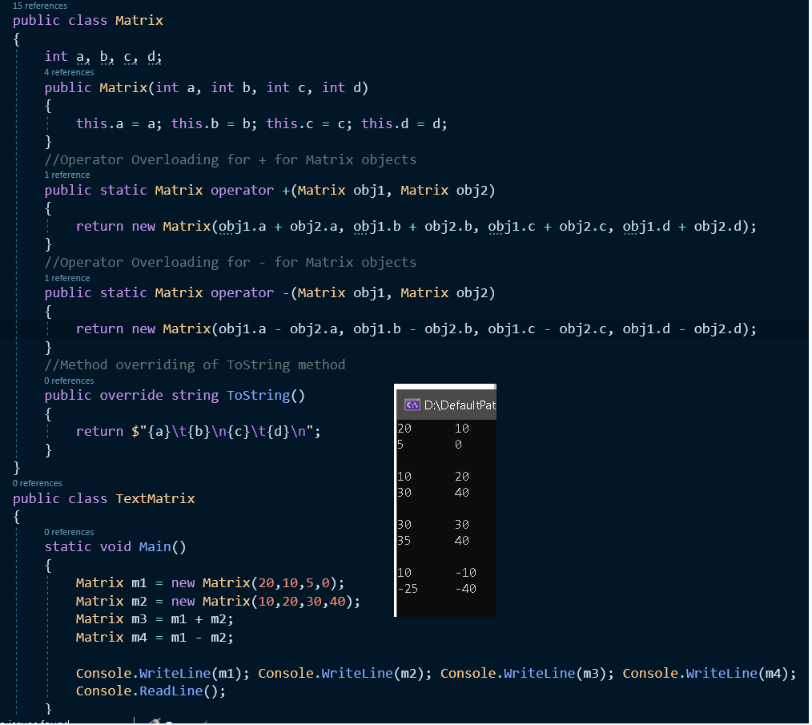

**Abstract Classes & Methods**

1. A method without any method body is known as an **Abstract method**, what the method contains is only declaration of the method.

public abstract void Add(int a, int b);

1. A class which **contains** any **abstract members (methods)** in it is known as Abstract class.

abstract class Math

{

public abstract void Add(int x, int y);

}

1. To define a method or a class as abstract we require to use the “**abstract**” keyword on them.
2. If a method is declared as abstract under any class then child class of that class is responsible for **implementing the method without fail.**
3. The concept of abstract method will be nearly similar to the concept of Method Overriding.
4. Difference between method overriding and abstract methods

|  |  |
| --- | --- |
| Method overriding | Abstract Method |
| public class Parent  {  public abstract void show()  {  //Implementation  }  }  public class ChildClass : Parent  {  //**Optional**  public override void show()  {  //Re-Implemenentation  }  } | public abstract class AbstractParent  {  public abstract void show();  }  public class ChildClass : AbstractParent  {  //**Mandatory**  public override void show()  {  //Implemenentation  }  } |

1. Abstract Class can contain both abstract & non-abstract methods.
   1. Abstract Methods - **Liability**
   2. Non- abstract methods - **Assets**
2. Child class of Abstract Class should
   1. Implement each and every abstract method of parent class by using “**override**” keyword. - **Liability**
   2. Then only we can consume non-abstract method of parent class. – **Assets**
3. We cannot create instance of Abstract class but we can create reference of abstract class using the child class instance.
4. Parent class reference can call child classes overridden methods but can never call purely defined methods defined under child class.

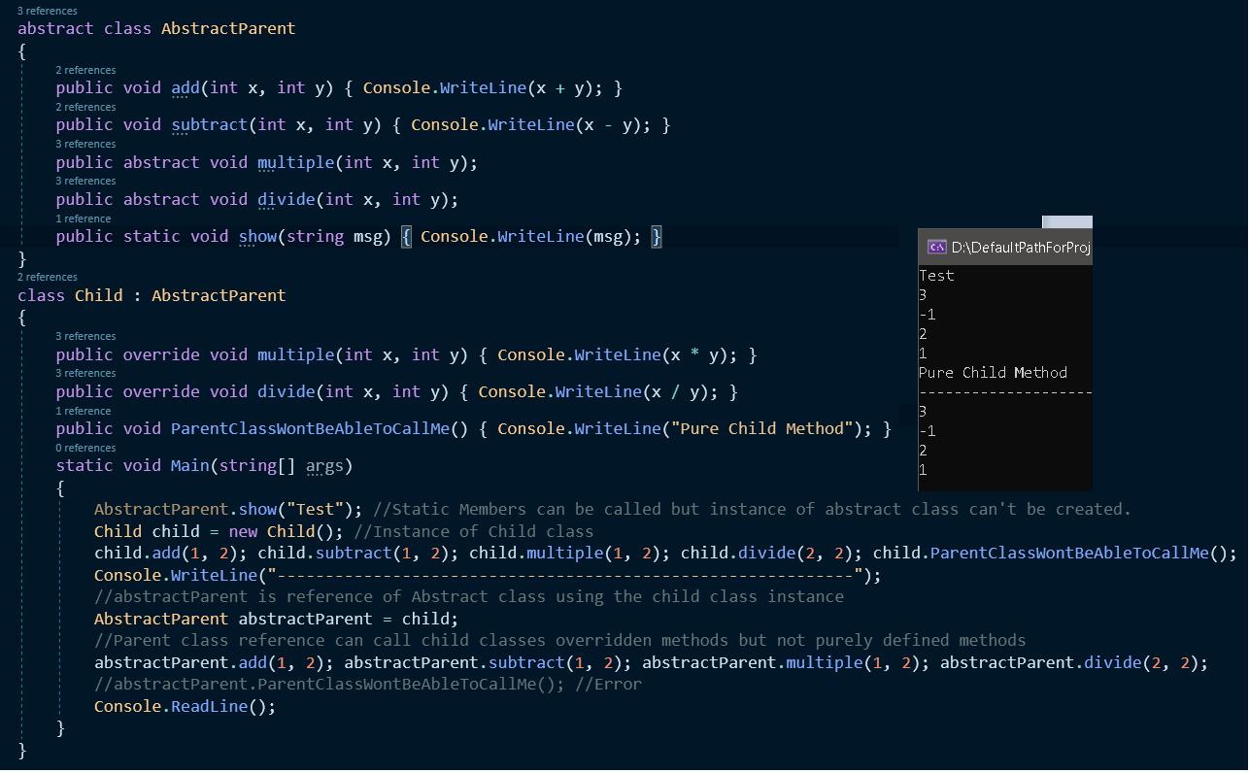

**How to implement Abstract Class & Method**

1. Advantage of Abstract method
   1. When logic varies from class to class then it is a good idea to implement an abstract method in parent class and child class will be forced to implement the abstract method
   2. We will make the child class to implement the method with particular signature & name but implementation logic can be different.
2. Identify the entities.

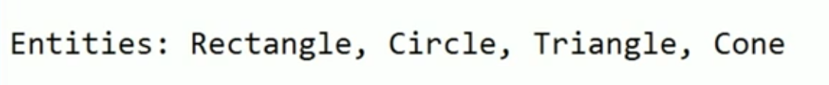

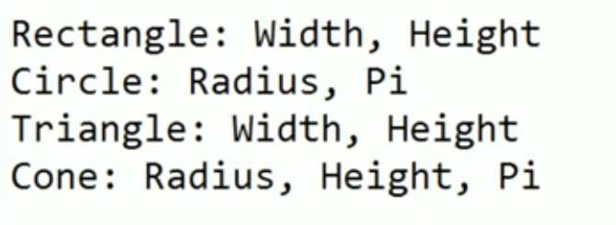

1. Identify the common attributes of these entities.

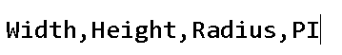

1. Identify the common functionality of these entities and declare it as abstract



1. Now Define the common attribute and functionality in abstract class

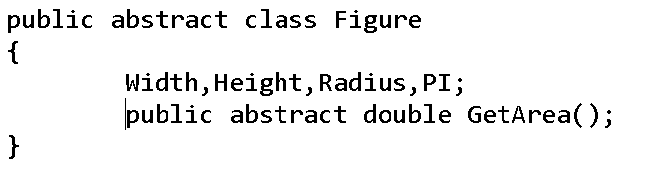

1. Actual Implementation
   1. 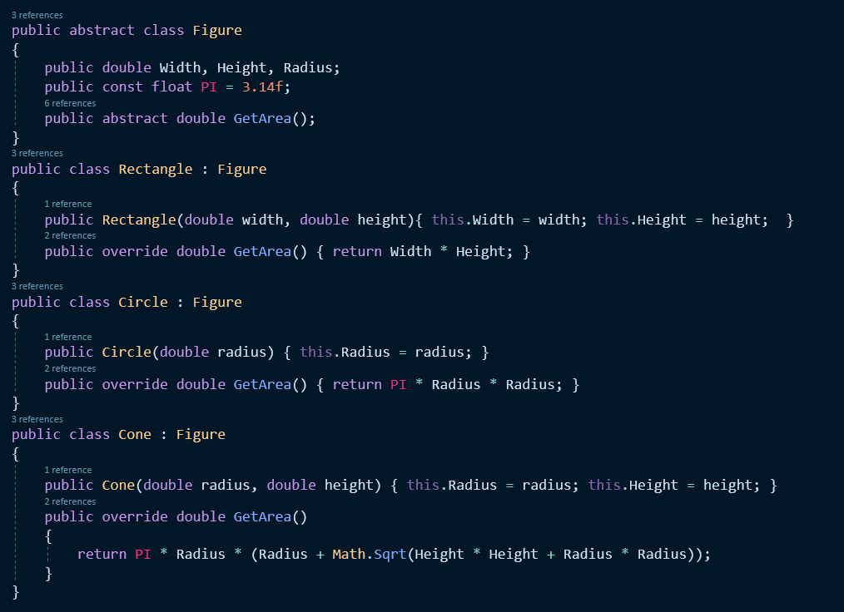
   2. 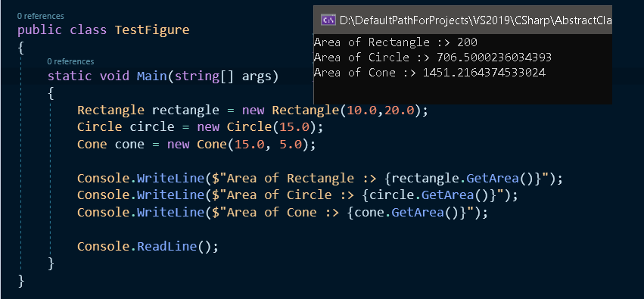

**Interface**

1. Difference & Common

|  |  |
| --- | --- |
| **Class** | **Interface** |
| 1. Class is a user-defined data type. 3. Class : Non-Abstract methods (Methods with method body) 4. Abstract Class :  * Non-Abstract methods (Methods with method body) * Abstract Methods (Methods without method body)  1. Generally a class inherits from another class to **consume or**   **re-implement** the members of its parent class.   1. Default scope of the **class** is **private.** 2. We can declare any fields/variables under a class. 3. **Re-Implementation – Optional** | 1. Interface is a user-defined data type. 3. Interface : contains only **abstract methods (**Methods without method**)** 4. If a class is inherited from an interface then it has to **implement** the members of its parent class. 5. Default scope of the **interface** is **public.** 6. We can’t declare any fields/variables under an interface. 7. **Implementation – Mandatory** |

1. Every abstract method of an interface should be implemented by the child class of the interface without fail (Mandatory).
2. A class can implement/inherit from an interface.

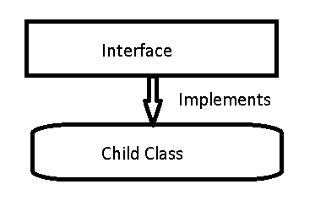

1. A class can inherit from a class and interface at a time.

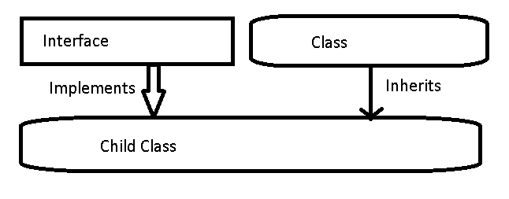

1. By Default every member of interface is abstract so we don’t require to use **abstract** modifier on it again just like we do in case of abstract class.

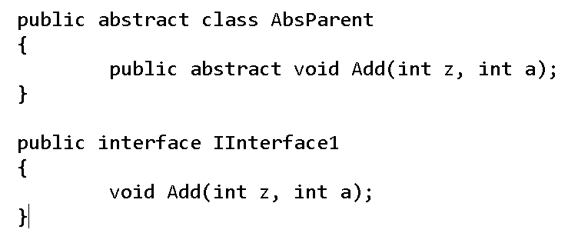

1. If required an interface can inherit from another interface.
2. Every member of an interface **should** be **implemented** under the child class of the interface **without fail**, but while implementing we **don’t require** to use “**override**” modifier just like we have done in case of abstract class.
3. We **cannot** **create** an **object** of **interface** but we can **create** **reference** of **interface** using the **child class instance**.
4. E.g.

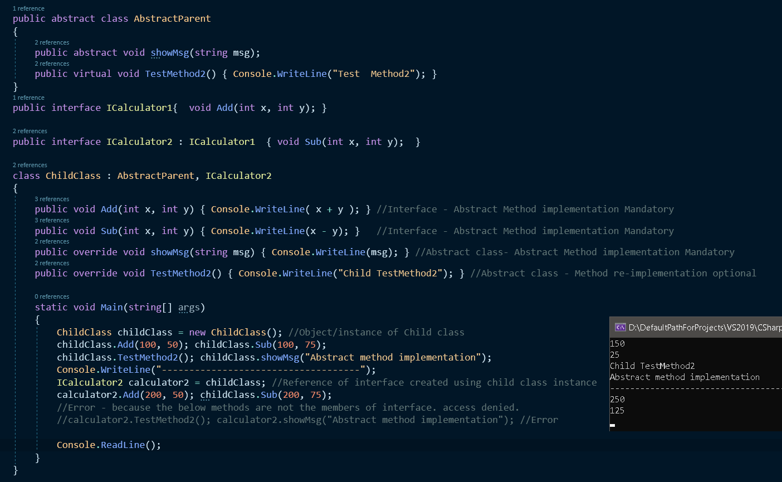

**Multiple Inheritance using interfaces**

1. Multiple inheritance using interface

|  |  |  |  |  |
| --- | --- | --- | --- | --- |
| Single | Multi-Level | Hierarchical | Hybrid | Multiple |
|  |  |  |  |  |

1. Even if multiple inheritance is not supported through classes in CSharp, it is still supported thru Interfaces
2. A class can have one and only one immediate parent class, whereas the same class can have any number of interfaces as its parent i.e. **multiple inheritance is supported in CSharp thru interface.**

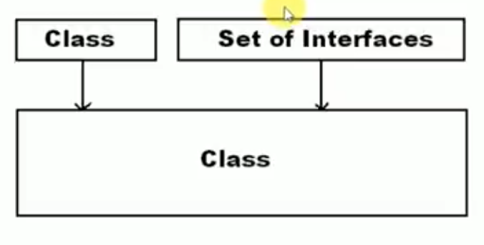

1. Why multiple inheritance is not supported thru class and how is it supported thru interface?

|  |  |
| --- | --- |
| Class | Interface |
| 1. Ambiguity problem - Consuming      1. Since child class needs to consume or re-implement the parent class methods, ambiguity issue arises. | 1. No Ambiguity problem - Implementing      1. Since child class need to implement the interface abstract method, ambiguity will not arise |

1. We never come across ambiguity problem when we work with multiple inheritance with interface,
2. Two way to implement interfaces
   1. Implicitly implementation

**We can call the methods using child class instances.**

* 1. Explicitly implementation

**We can call the methods using reference of interface**

1. E.g.

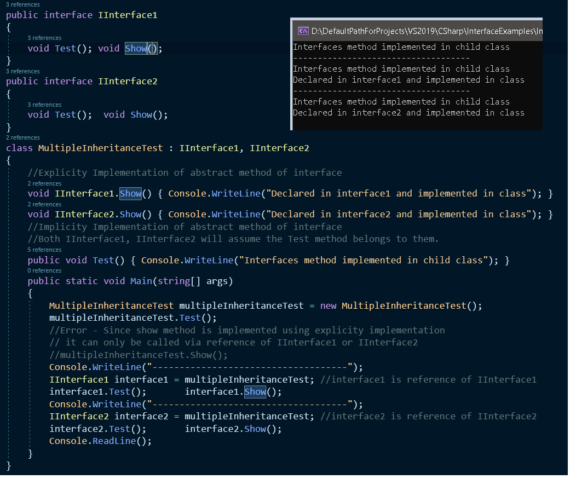

**Struct**

1. Class is a user-defined type.
2. Structure is also a user-defined type.
3. Difference between Class & Struct

|  |  |
| --- | --- |
| **Class** | **Struct** |
| 1. Class is reference type. 2. **Memory allocation** for **instance of class** is performed on **managed heap memory.** 3. Classes are used when we need to represent entities with **large volume** of data. 4. In-case of class, “**new**” keyword is **mandatory** for **creating** the **instance** of the **class**. 5. Fields of a class can be initialized at the time of declaration.      1. We can define any constructor under the class that is either parameter less or parameterized and if no constructor is defined then there will be an implicit constructor which is default constructor.      1. If “**Zero**” constructors are defined in a class after compilation there will be **1 constructor (Implicit)** if we define **“n”** constructors in a class after compilation there will be **“n” constructors** only. 2. Class can be inherited by other classes i.e. class supports inheritance. 3. Class can implement interfaces | 1. Struct is value type. 2. **Memory allocation** for **instance of Struct** is performed on **stack memory.** 3. Structs are used when we need to represent entities with **smaller volume** of data. 4. In-case of class, “**new**” keyword is **optional** for **creating** the **instance** of the **structure**. 5. Fields of a Structs cannot be initialized at the time of declaration.      1. Parameter less constructor i.e. default constructor is always implicit and can’t be defined explicitly again, what we can define is only parameterized constructor.      1. If “**Zero**” constructors are defined in a Struct after compilation there will be **1 constructor (Implicit)** if we define **“n”** constructors in a class after compilation there will be   **“n + 1” constructors** only.   1. Structure can’t be inherited by other structures i.e. structure doesn’t support inheritance. 2. Structures can implement interfaces |

1. Generally Class & Structure are used to represent entities.
2. **Structure** in **C Language** can contain only **Fields** in it whereas **Structure** in **CSharp** can contain most of the members what a class can contain like **Fields, Methods, Parameterized Constructors, Properties, Indexers and Operator Methods etc**.

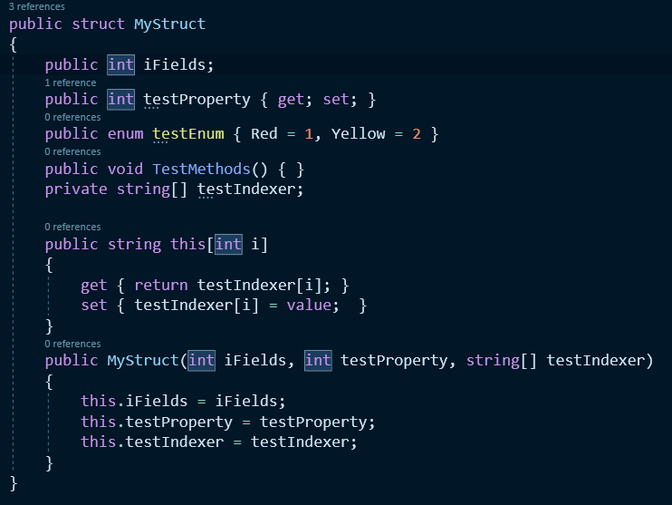

1. All **pre-defined data types** under the libraries of our language which comes under **reference** type category i.e. **String & Object** are pre-define **class** whereas all **pre-defined data types** under the libraries of our language which comes under **value type** category i.e. **Int (Int32), float (Single), bool (Boolean), GUID** are **structure**.
2. If structure contains any fields then we need to initialize those fields either by
   1. Explicitly calling default constructor with the help of “new” keyword.

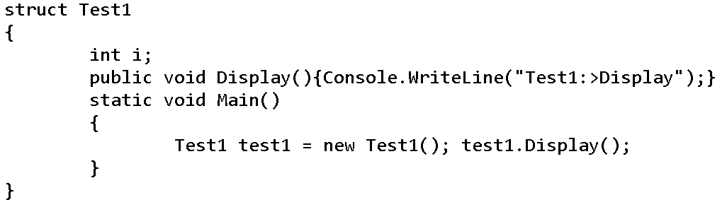

* 1. Else if we are not using “new” keyword for creating the instance we need to explicitly assign value to fields referring it thru the instance and assign value.

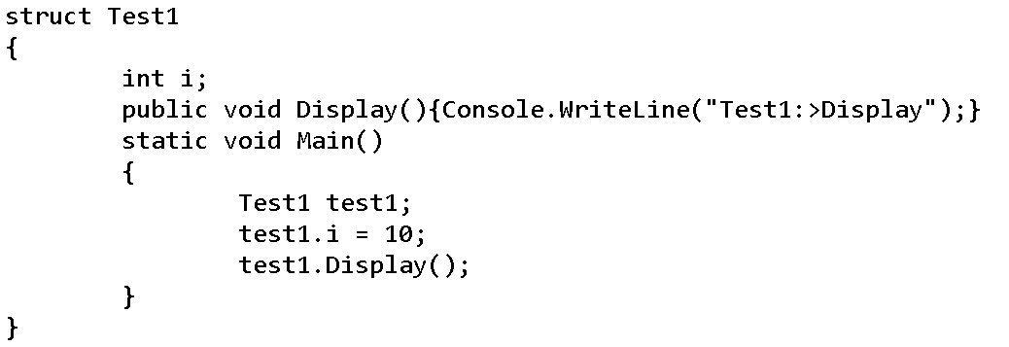

1. E.g. Code.

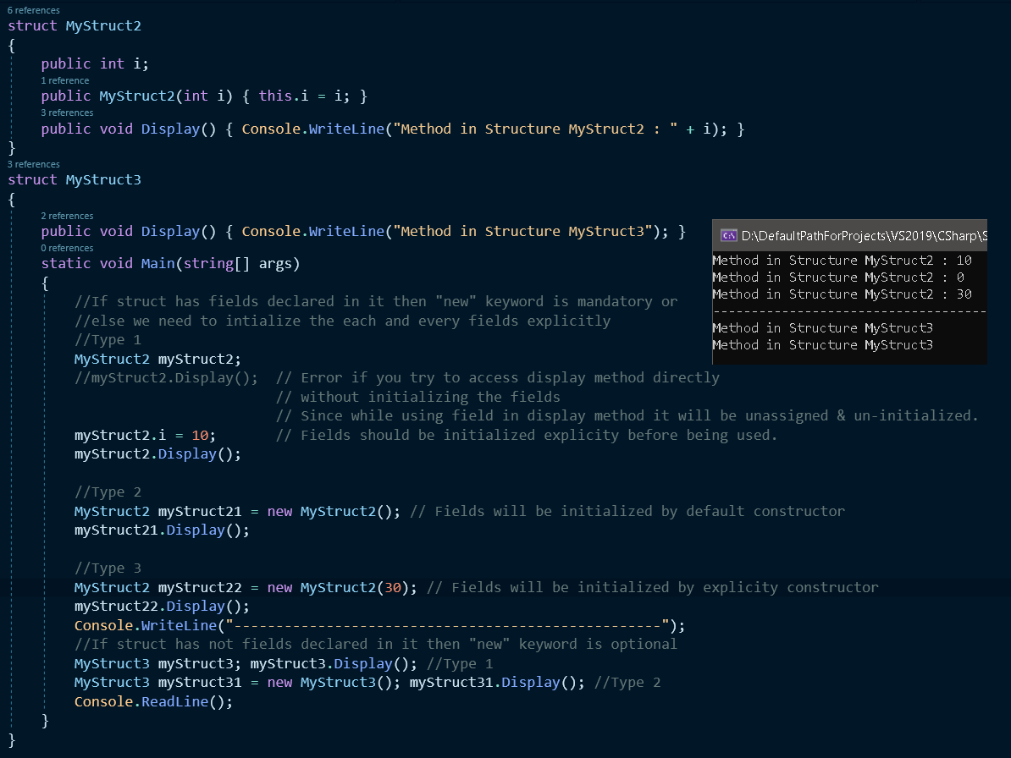

**Enumeration**

1. Enumeration are user-defined type. Enumeration are set of named constant values.
2. How to define Enum Types

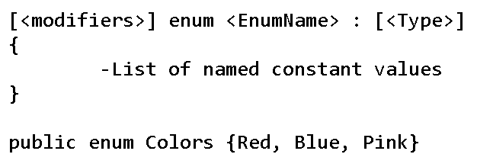

1. Use of Enums
   1. When you have list of supported values you can list those values under the Enum.
   2. It reduces human errors
   3. When we need to define a property or fields with only a set of values to choose from we use Enums.
2. As Enums are user defined type, so it always better to define an Enum directly under the namespace but it is also possible to define Enum under a class or structure.
3. Enum are value type category.
4. Only first value can be taken over by assigning zero not for remaining values, for remaining values we need to explicitly convert the Enum as shown below

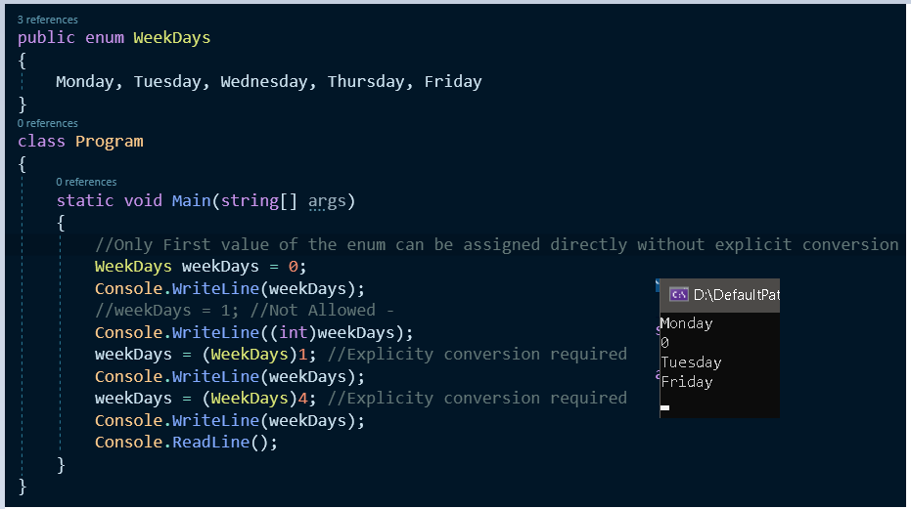

1. Accessing all the Enum values using foreach
   1. GetNames
   2. GetValues

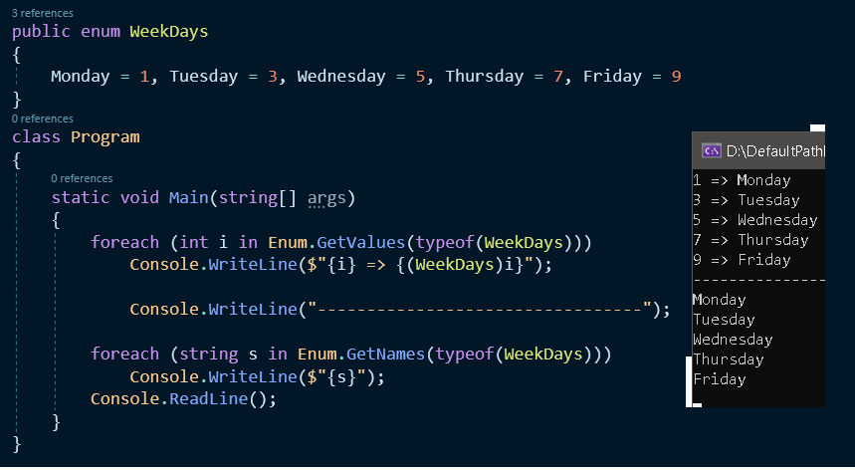

1. Int is default type for enum
   1. Supported types are int, byte, short, long, uint, ushort, ulong and sybte.

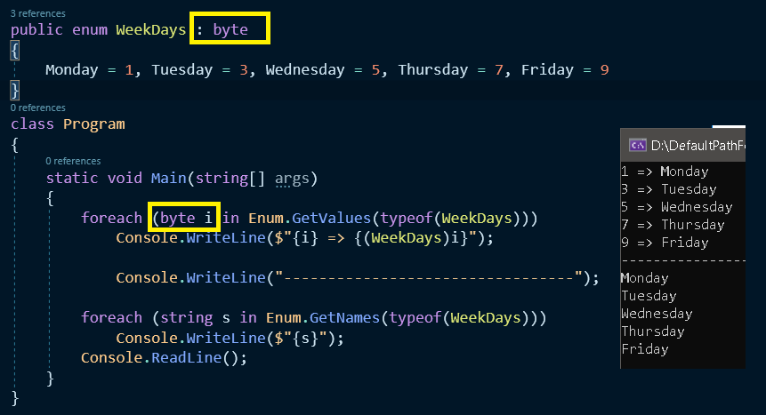

1. E.g. of Enum using property

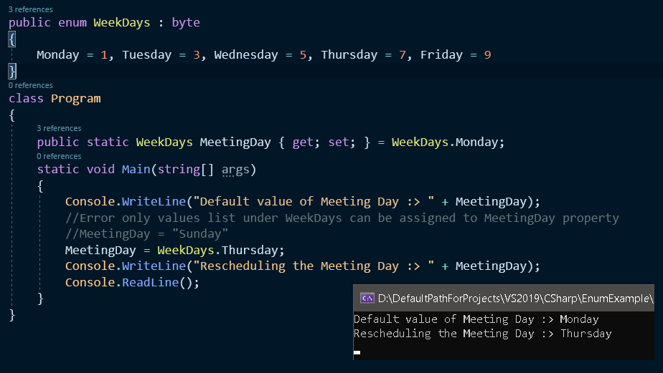

**Properties**

1. Property is a member of class using which we can expose values associated with a class to the outside environment.
2. Why we need Property
   1. Private variables are not accessible via instance of the class though memory allocation is done.

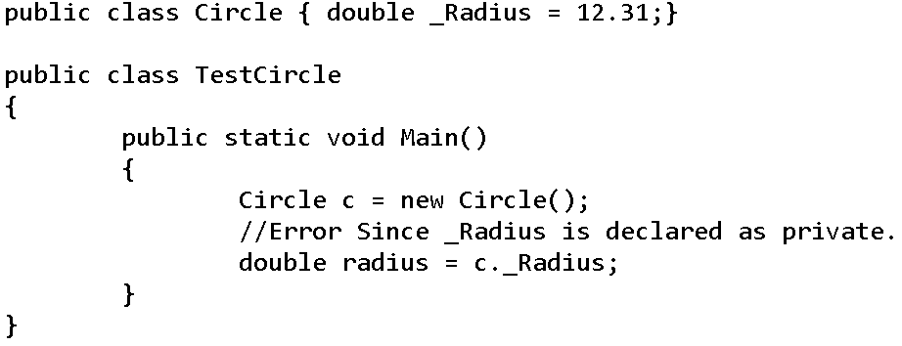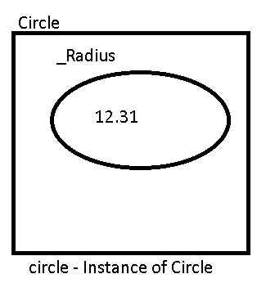

* 1. Public variables are accessible via instance of the class and now any one can access the variable and get and set the value of the variable. Now we cannot restrict the use of the variable.

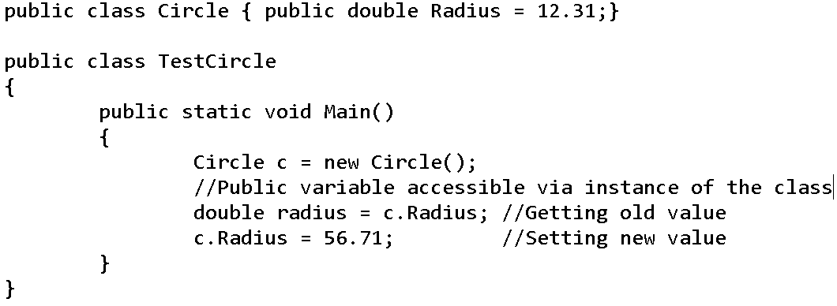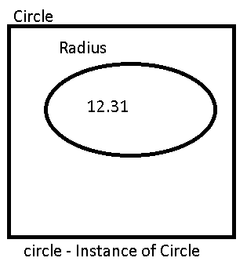

* 1. To restrict the use of the variable never declare them as public.
  2. We can define a Getter Methods to get the value of the private variables now user cannot set the private variable

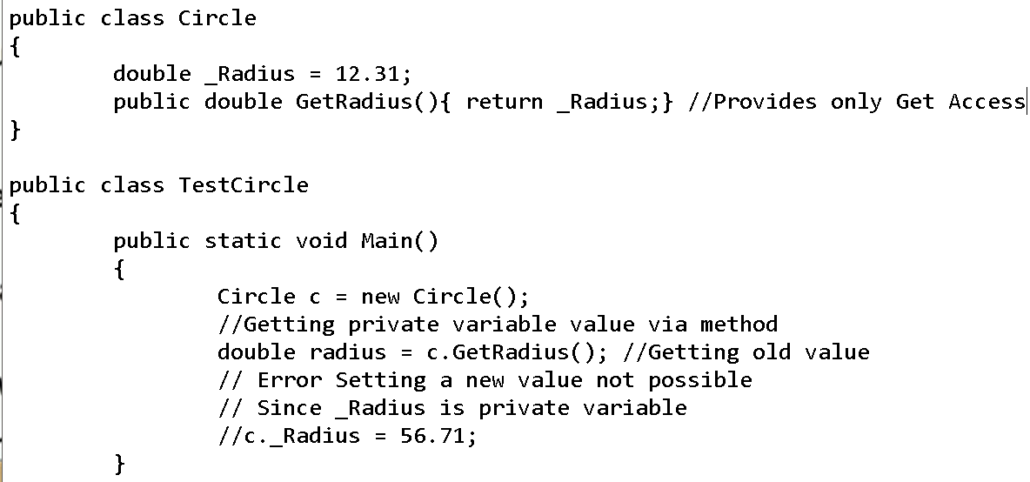

* 1. We can define a Setter method to set the value of the private variables now user cannot get the private variable

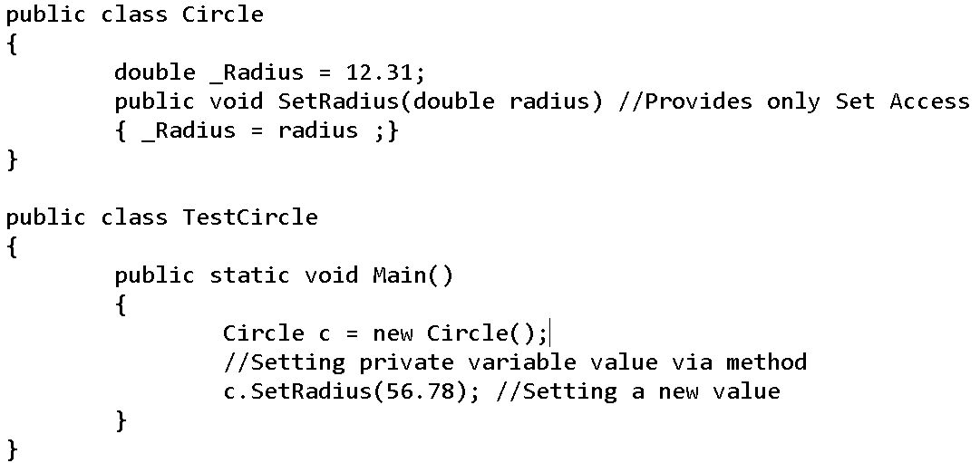

* 1. We can define both Getter & Setter Method for the private variable now user can set and get the variable of the private variable via those methods.

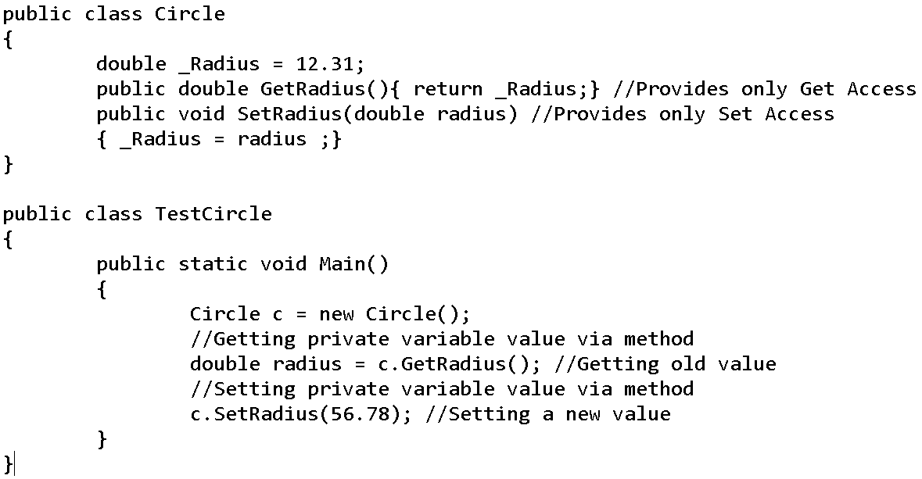

* 1. Property is combination of Getter & Setter method combine in one block of code.

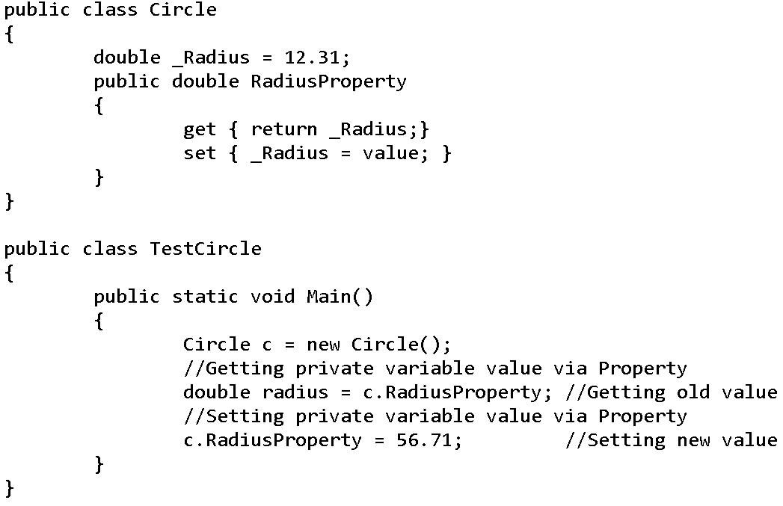

1. Declare a Property

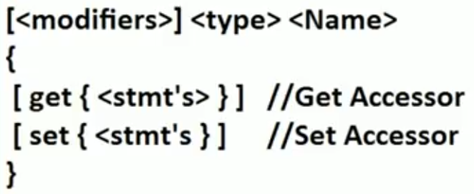 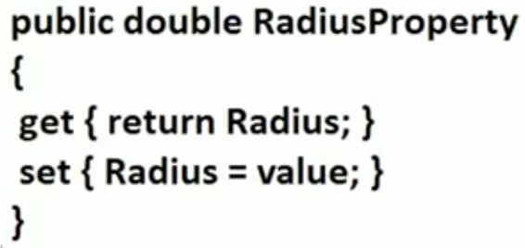

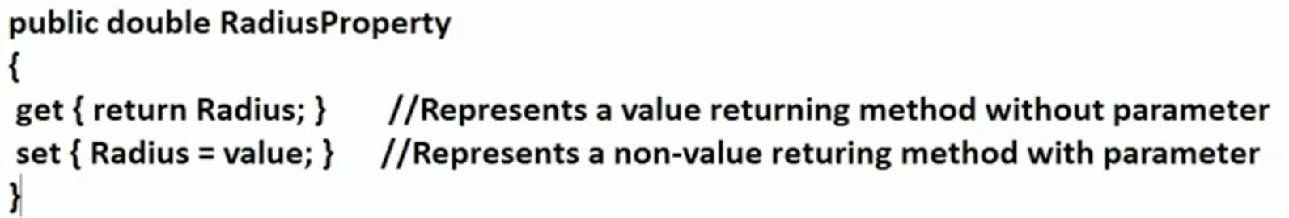

1. Three type of Properties

|  |  |  |
| --- | --- | --- |
| Read-Only Property | Write-Only Property | Read-Write Property |
|  |  |  |

1. Advantages of using property
   1. Only get access, only set access or both get and set access can be applied on the property.
   2. We can impose the restriction on the data
   3. Conditional access and Conditional assignment through property.
2. Property Example 1-

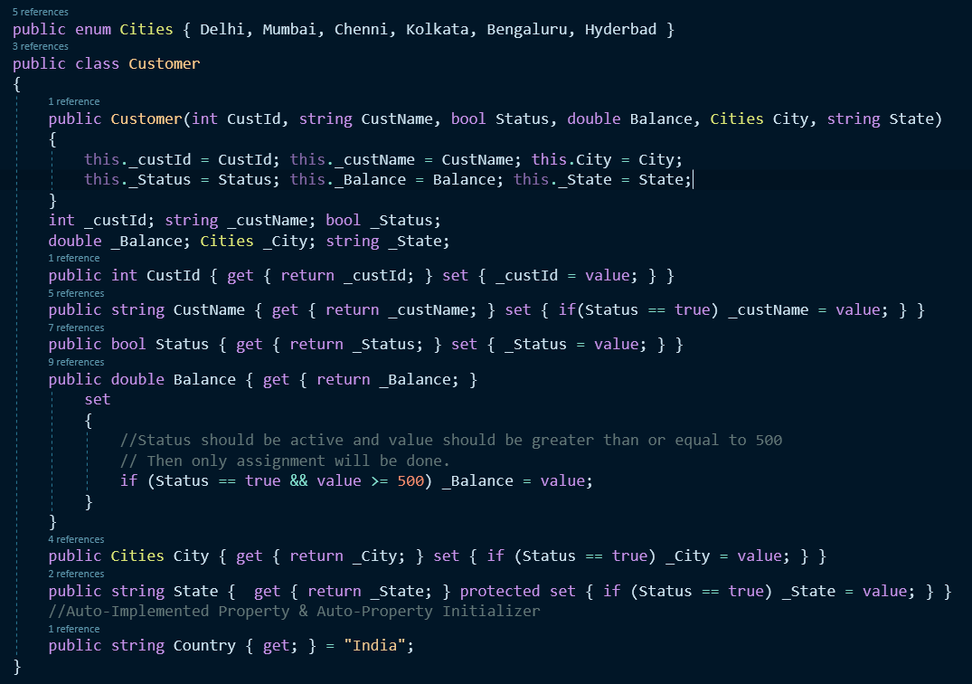

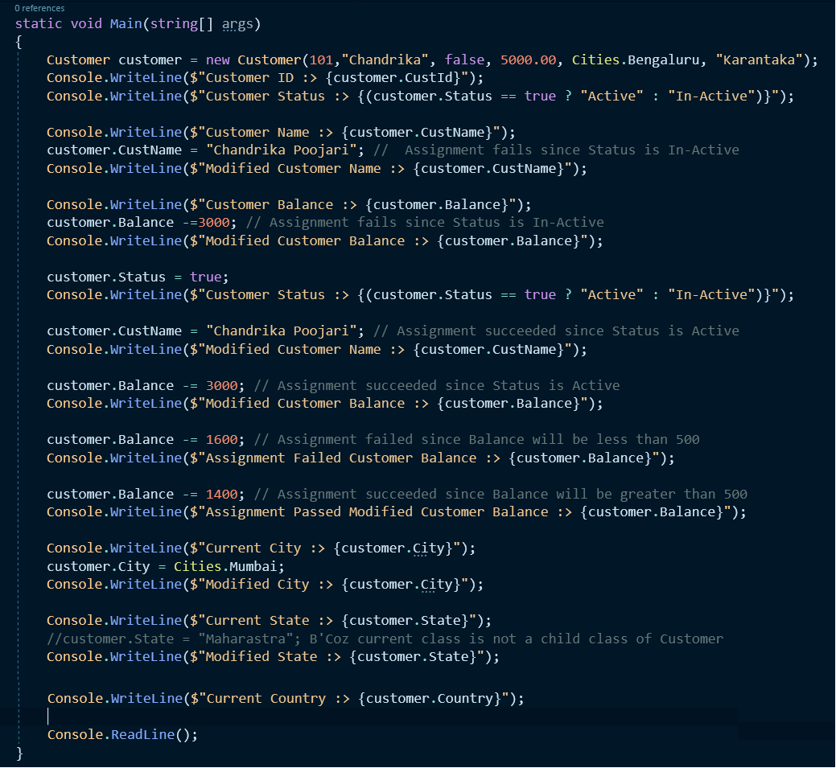

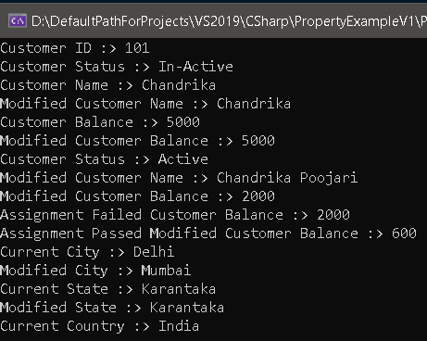

1. Introduction of Property in C# -
   1. Auto-Implemented Property was introduced in C# 3.0 but there was a restriction user need to create a read-write property.

public string Country { get; set; }

* 1. In C# 6.0, the above restriction was removed and now we can create only read-only or only write-only or read-write auto-implemented property.

public string Test1 { get; } //Read-only Property

public string Test2 { set; } //Write-only Property

public string Test3 { get; set; } //Read-Write Property

* 1. In C# 6.0, they introduced Auto-Property Initializer

Public string Name { get; set; } = “Chandrahas”;

* 1. The access specifier i.e. scope was only applicable to the property earlier but in C# 2.0 we can define scopes(access specifier) for the accessor also

Earlier

string _state;

Public string State { get { return _state;} set {_state = value;}}

C# 2.0 and later

string _state;

Public string State

{

get { return _state;}

protected set {_state = value;}

}

* 1. Both the accessor cannot have access specifier at the same time.
  2. For more…

<https://docs.microsoft.com/en-us/dotnet/csharp/programming-guide/classes-and-structs/access-modifiers>

**Indexers**

1. Indexers – Indexers allow instances of a class or struct to be indexed just like arrays.
2. If we define a indexer in a class it starts behaving like a virtual array

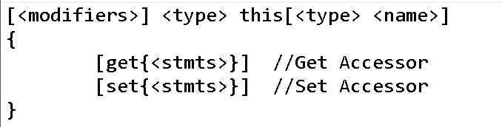

|  |  |
| --- | --- |
| Accessing via indexer via integer | Accessing indexer via string |
|  |  |

1. Example

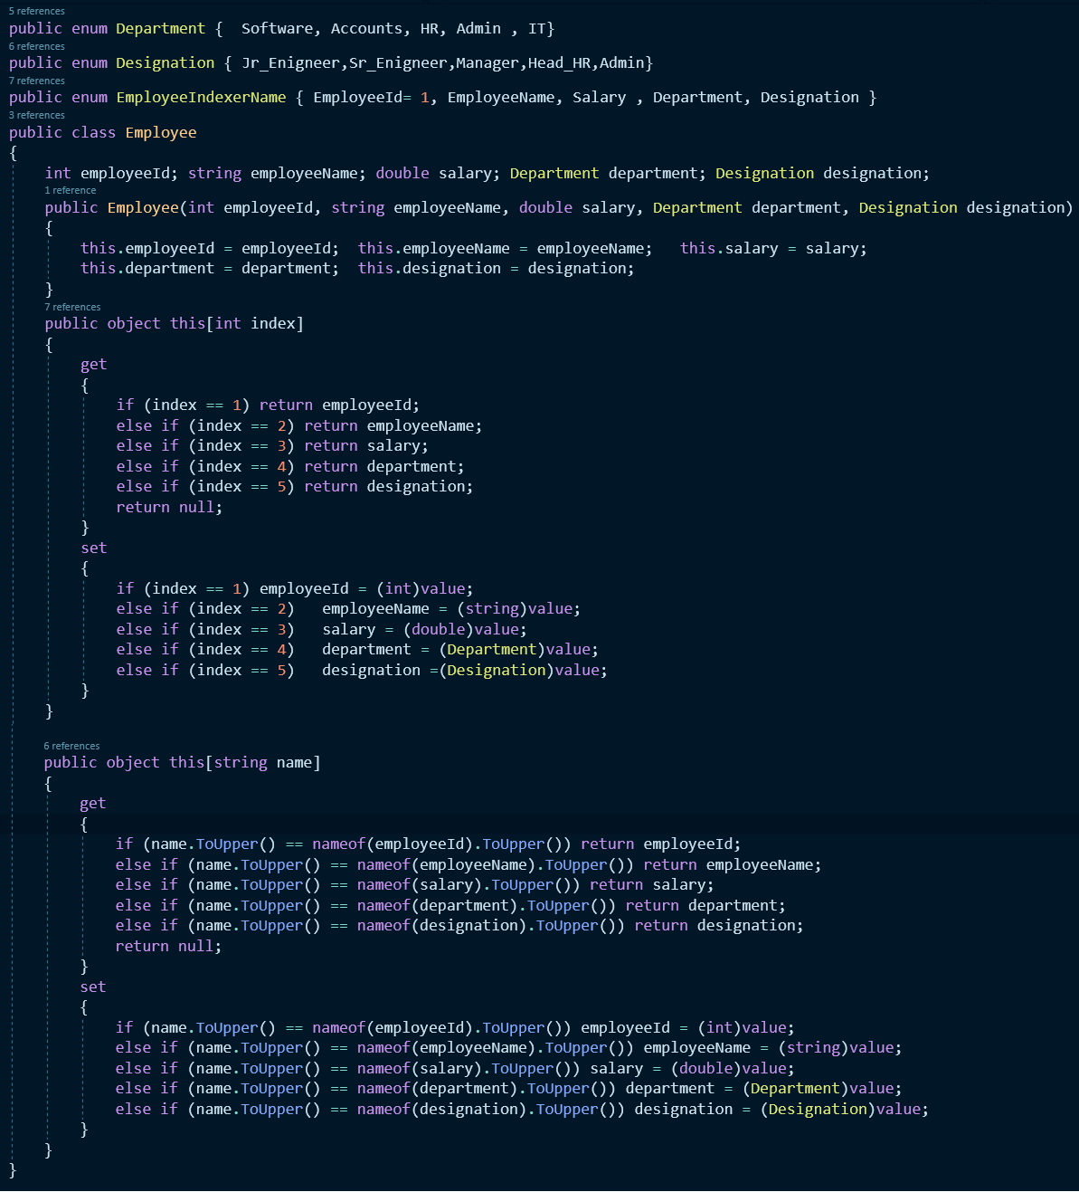

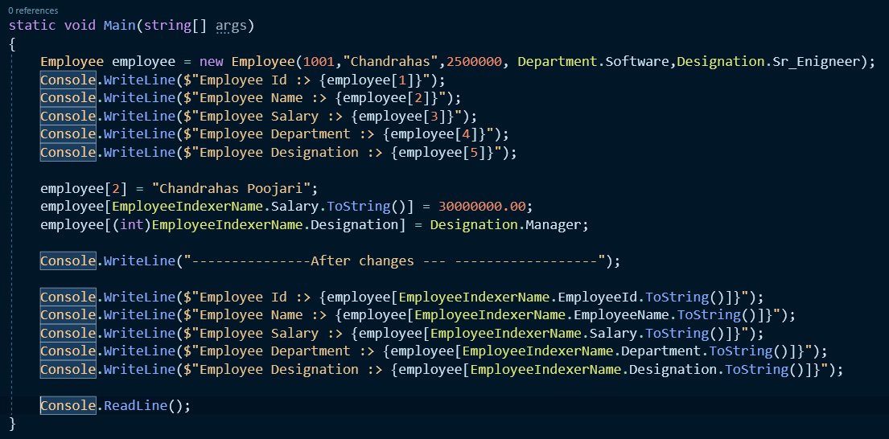

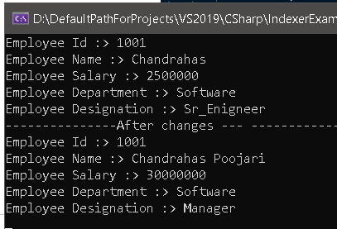

1. Example – 2

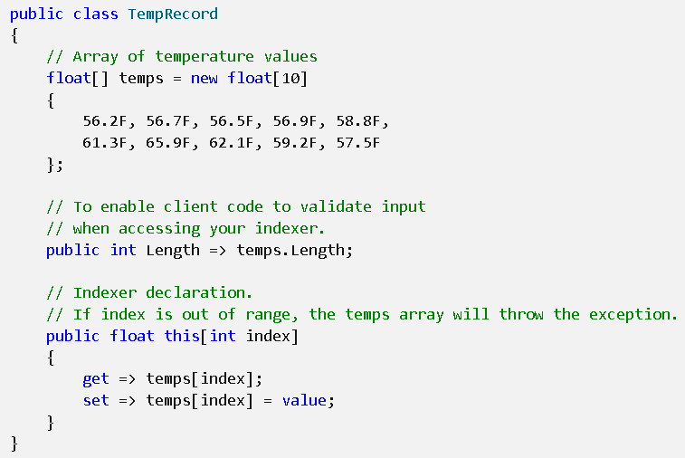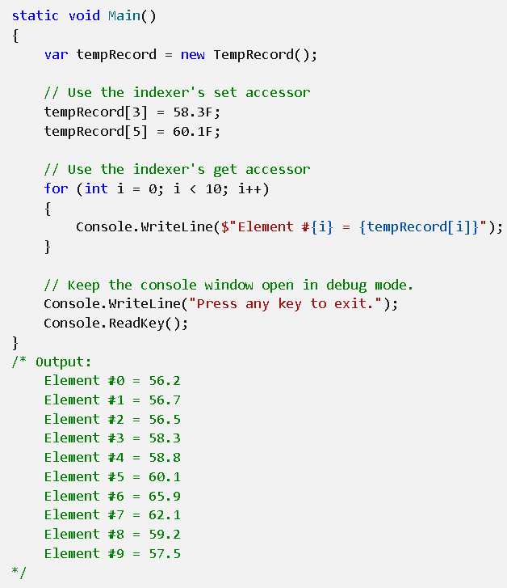

1. Example 3

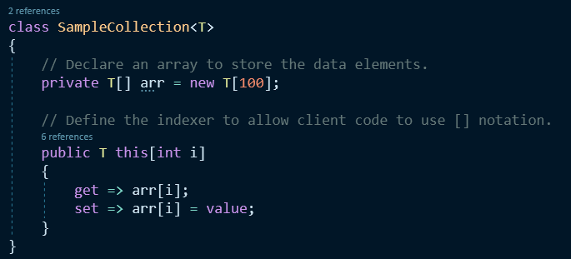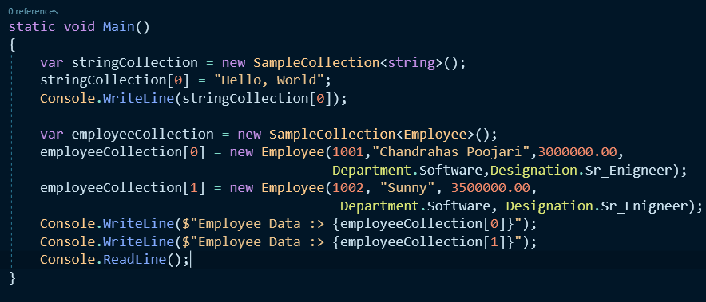

In Employee class toString method was overridden to get this result

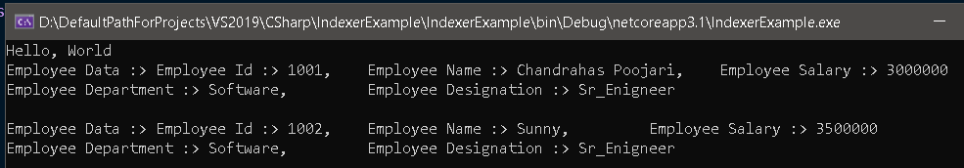

1. Indexer Overview

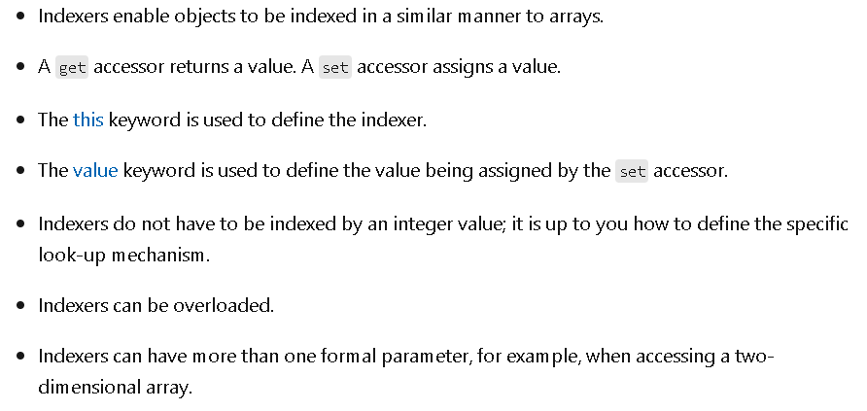

1. For More

<https://docs.microsoft.com/en-us/dotnet/csharp/programming-guide/indexers/#:~:text=Indexers%20allow%20instances%20of%20a,that%20their%20accessors%20take%20parameters>.

**Delegates**

1. Delegate is a type safe function pointer
2. A Delegate holds the reference of a method and then calls the method for execution.
3. In C#, we can call a method by three ways
   1. By using the instance of a class, if it is a non-static method.
   2. By using the name of a class, if it is a static method.
   3. By using Delegate.

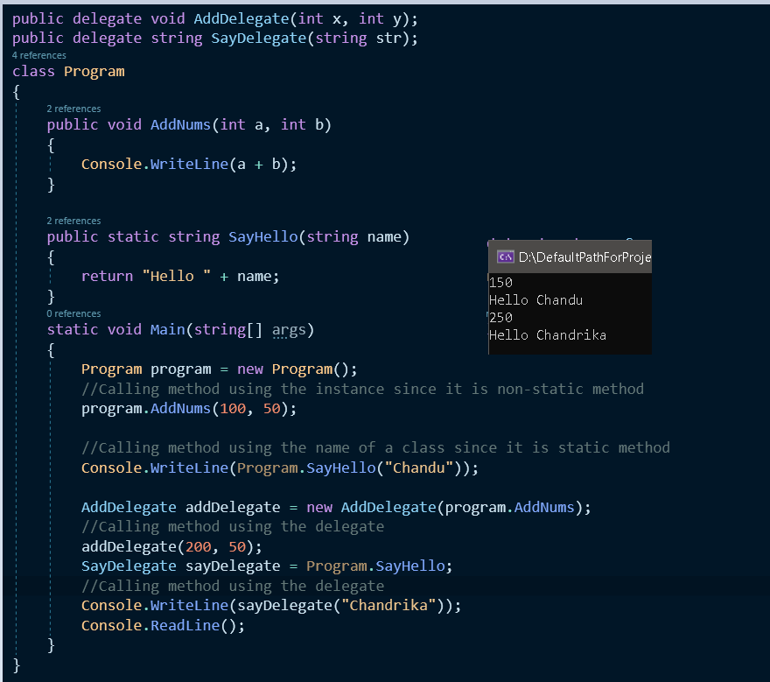

1. To call a method by using a delegate we have 3 steps
   1. Define a delegate

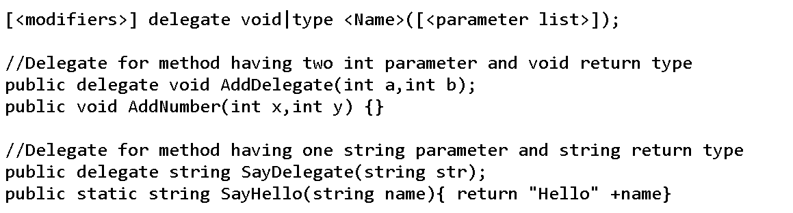

* 1. Instantiating the delegate-Creating instance of delegate since it is a reference type.

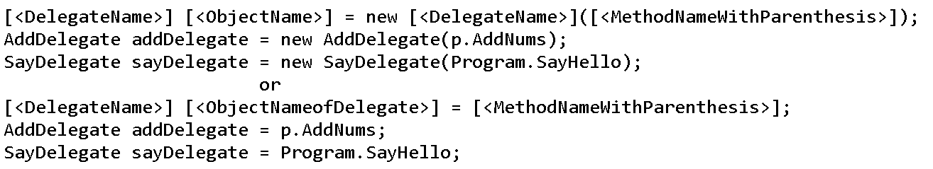

* 1. Now calling the delegate by passing the required parameter values, so that internally the method which is bounded with the delegate gets executed.

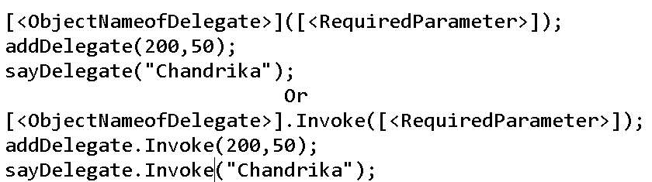

1. While defining a delegate, we should remember two things
   1. The return type of delegate should be exactly be same as return type of the method.
   2. The parameters of delegate should be same as parameters of the method.

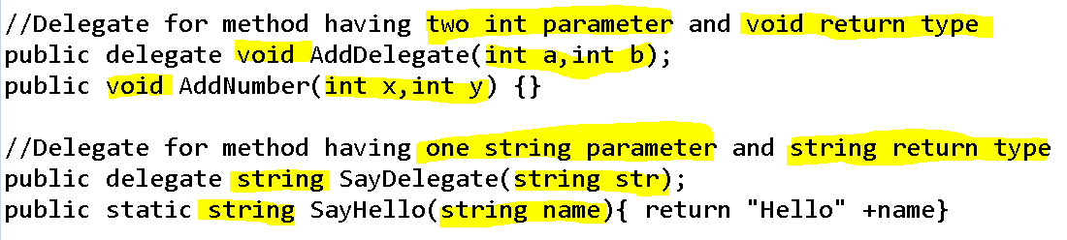

1. Delegate is reference type and it should be define under namescape (namespace is a logical container of types).
2. Example of Delegate – Define, instantiate & calling/Invoking the delegate

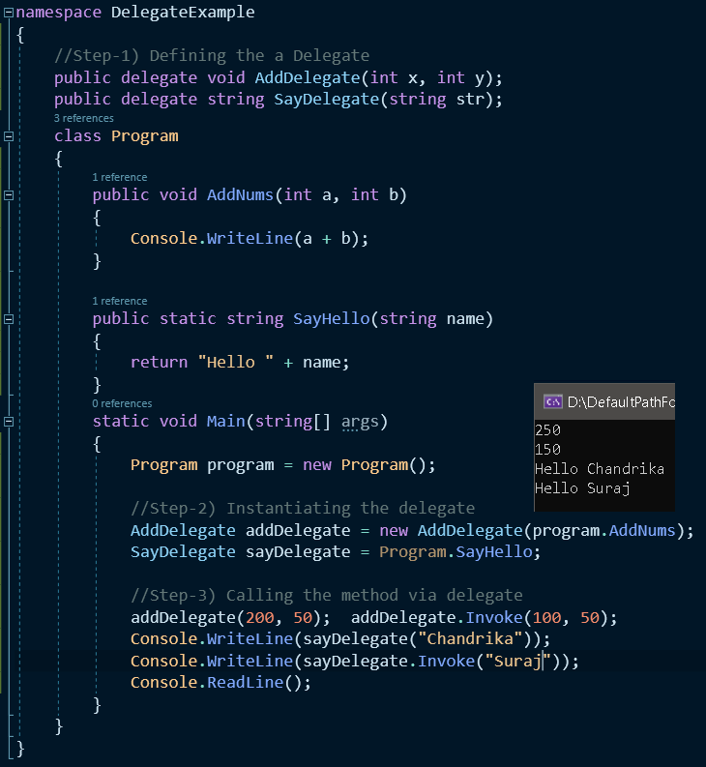

**Multicast Delegate**

1. Multicast delegate holds the reference of more than one method and calls the all those methods for execution at once when the delegate is invoked.
2. We use (+=) for multicast delegate e.g.

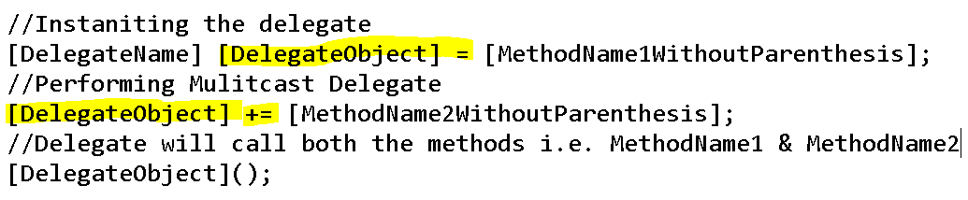

1. Advantage of using a multicast delegate
   1. When we need to call multiple methods with same signature with one invocation, we can use multicast delegate.
2. Rough Example of multicast delegate.

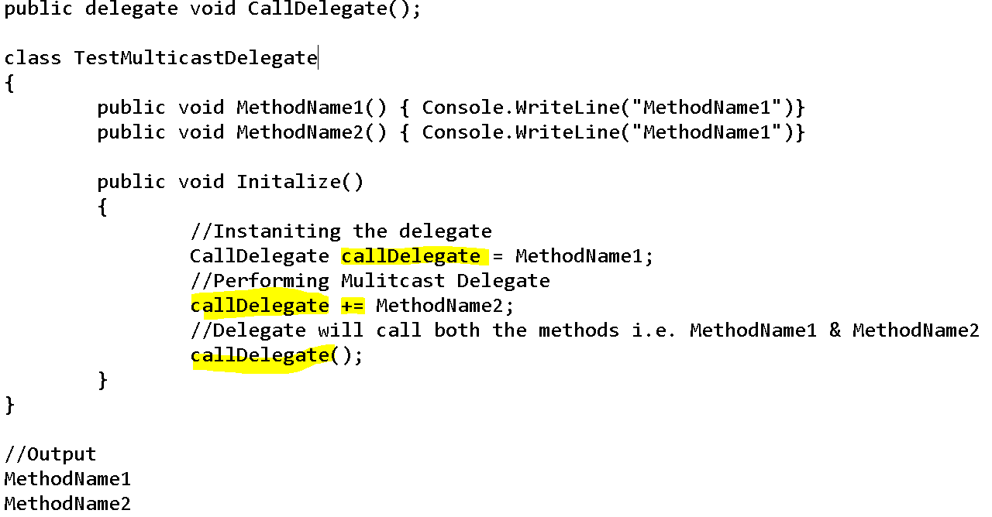

1. Don’t while using multicast delegates
   1. If method has return type or out parameter then **don’t use multicast delegate** because the return type or out parameter value will be overridden by the last executed methods value.
2. E.g. for multicast delegate

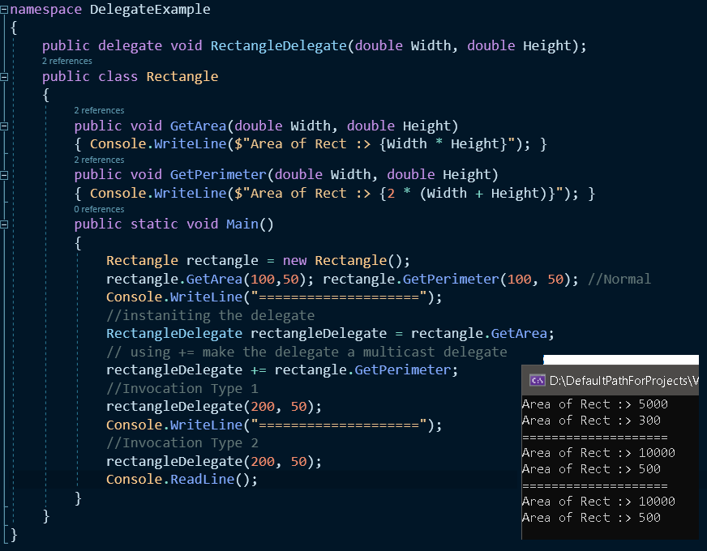

**Anonymous Methods – Delegates**

1. A method without name is called as Anonymous methods. It is also known as inline delegate.
2. Anonymous methods provides us a way to create a delegate object without writing separate method.
3. Anonymous method is declared when delegate is initialized.
4. Anonymous methods are used by when we have lesser line of code to execute.
5. How to define anonymous method

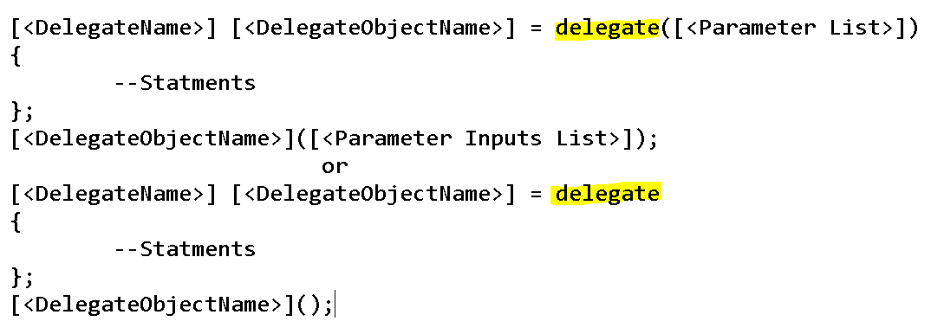

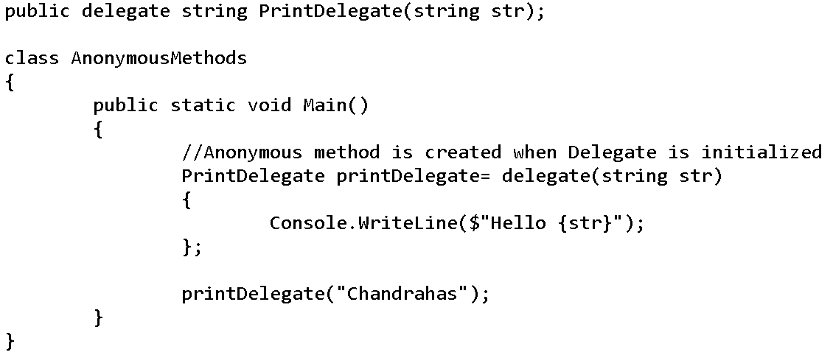

1. Anonymous method E.g. 1

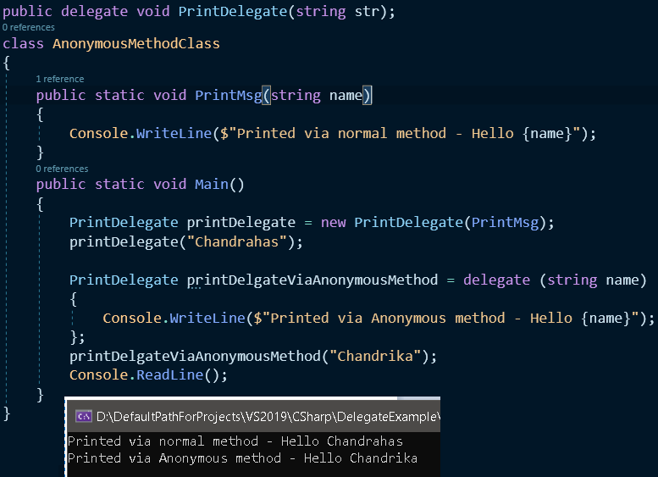

Reference –

<https://www.tutorialsteacher.com/csharp/csharp-anonymous-method>

<https://www.youtube.com/watch?v=OJktQUsGiBY&t=1s>

1. Anonymous method E.g. 2

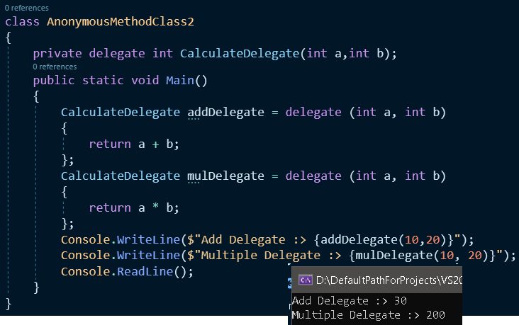

1. Anonymous method E.g. 3 – Passing Anonymous method as method parameter

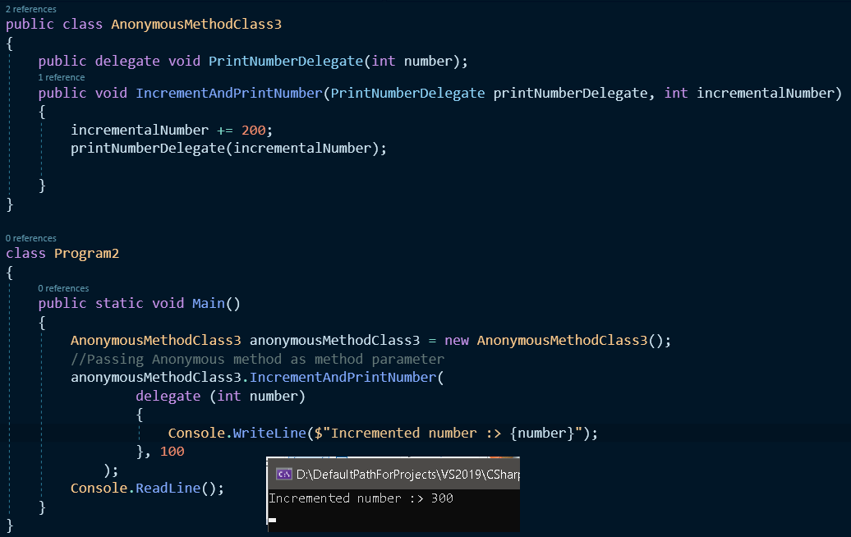

1. Anonymous method E.g. 4 – Anonymous method can be used as event handlers

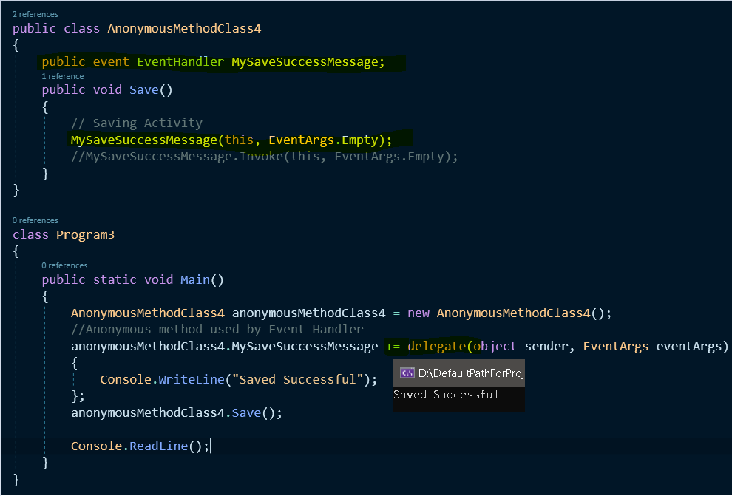

1. Some points to remember while using Anonymous methods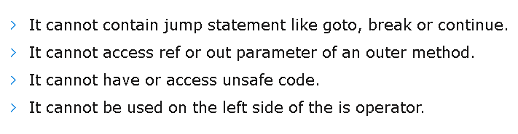

**Lambda Expression-Delegate**

1. Lambda Expression is a shorthand for Anonymous methods
2. Operator “=>” is used for Lambda expression.
3. Parameter type can be ignored while declaring the Lambda expression because delegate is aware of the return type and parameter type.
4. How to declare Lambda expression



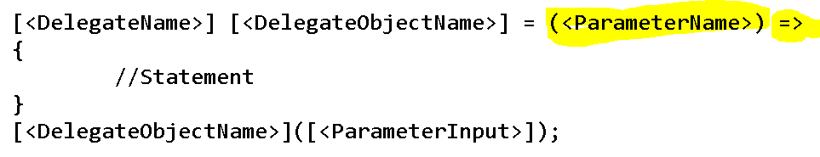

1. E.g. 1

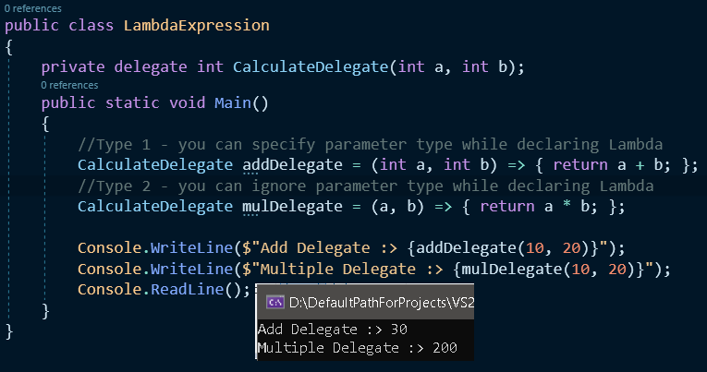

1. E.g. 2

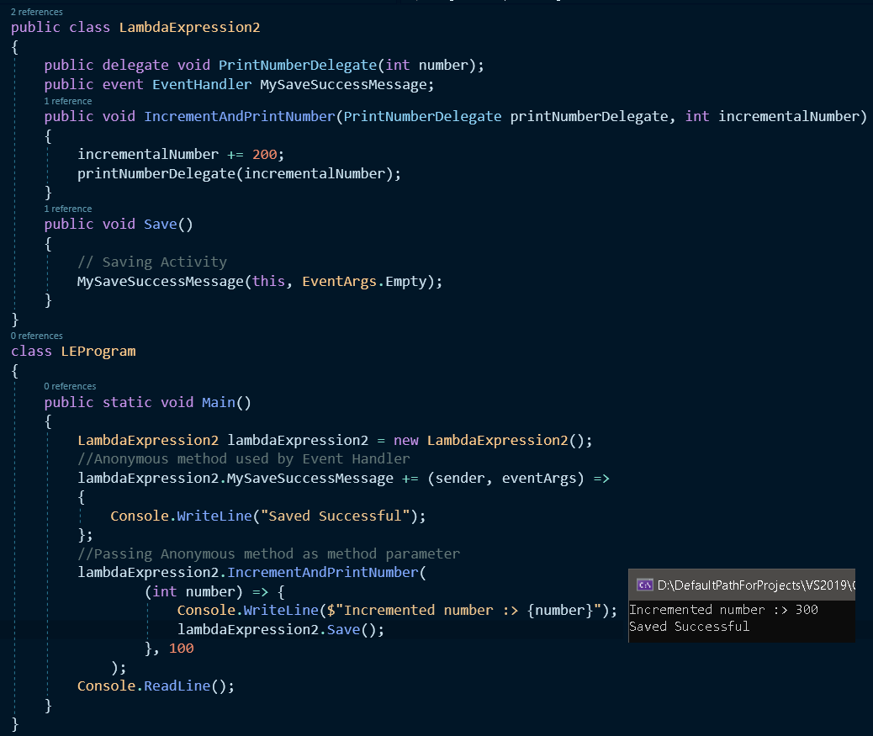

**Func, Action and Predicate Delegates – Generic Delegates**

|  |  |  |
| --- | --- | --- |
| Func | Action | Predicate |
| 1. It is a delegate for a function that may or may not take parameter and return a value. 2. Func<> takes maximum of 16 input parameter and 1 output parameter. 3. Returns a value. | 1. It is a delegate for a function that may or may not take parameter and doesn’t return a value. 2. Action<> takes minimum of Zero input parameter and maximum of **16 input parameter** and return type would be void. 3. Doesn’t return any value. | 1) It is a specialized version of Func<> that takes only one argument and always returns boolean value as result.  2) Predicate takes only one input parameter and **return type would be Boolean**.   1. Returns only Boolean. |

1. How to Func, Action & Predicate Delegate look like

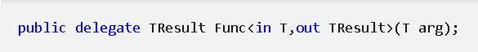

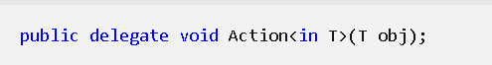



1. E.g. Action

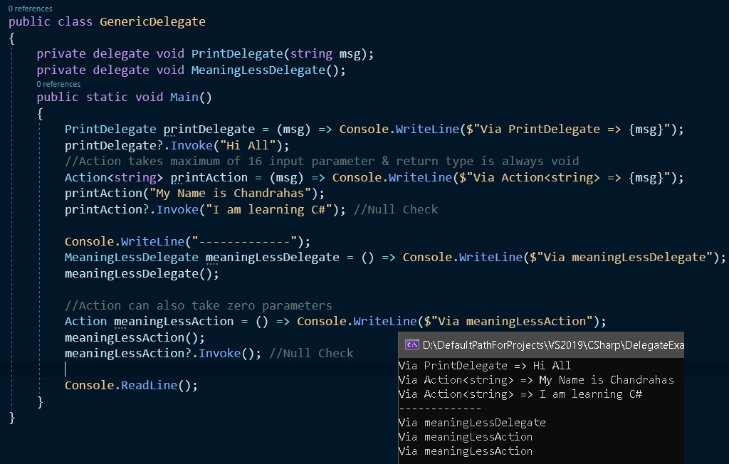

1. E.g. Func

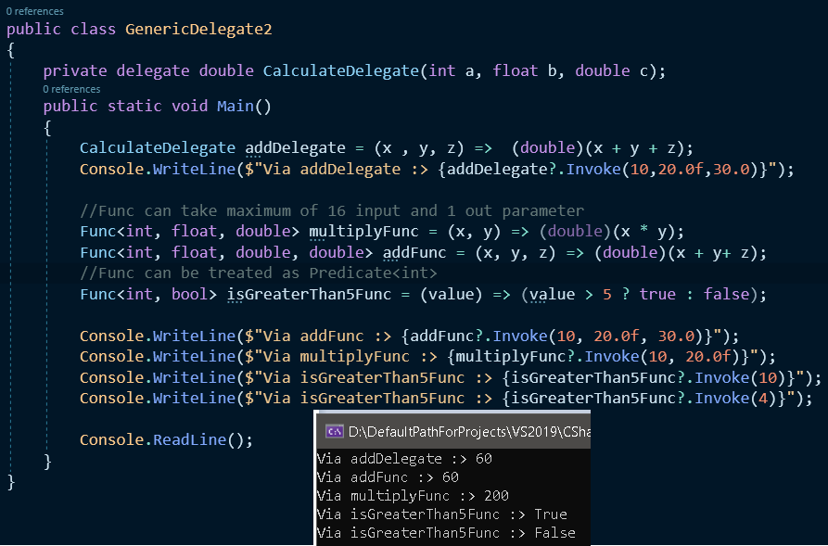

1. E.g. Predicate

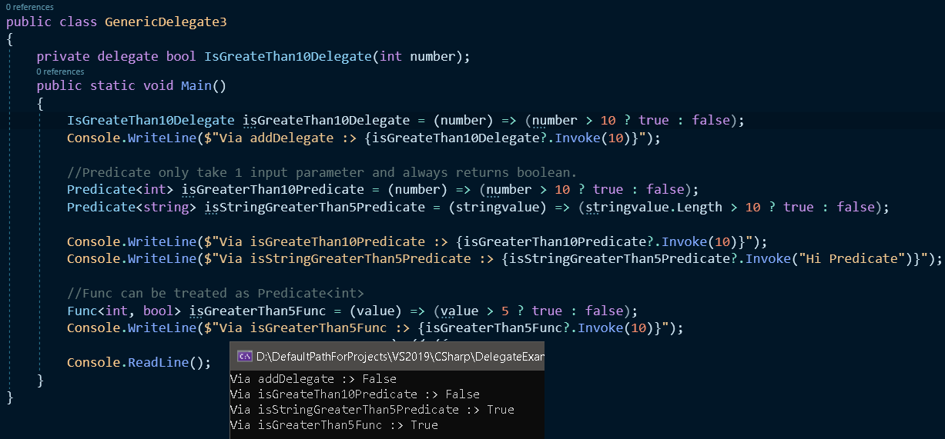

**Extension Methods**

1. This new feature has been introduced in C# 3.0.
2. Extension method is a mechanism of adding new methods into an existing class or structure without modifying the source code of the original type.
   1. The original type (Class or Structure) doesn’t require re-compilation.
   2. We don’t require permission from the original type (Class or Structure).
3. Inheritance is a mechanism using which we can extend the functionality of the class.

Limitation using inheritance for extending

* 1. We cannot apply inheritance on Sealed Class
  2. We cannot apply inheritance on Structure. So if the original type is not a class and it’s a structure.

1. Diagram

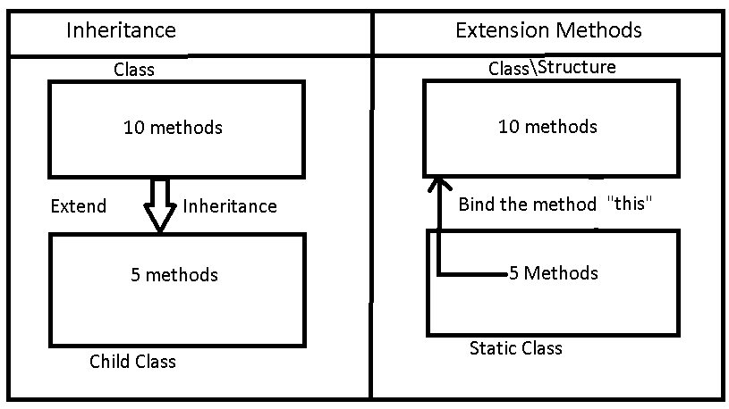

1. Defining extension methods

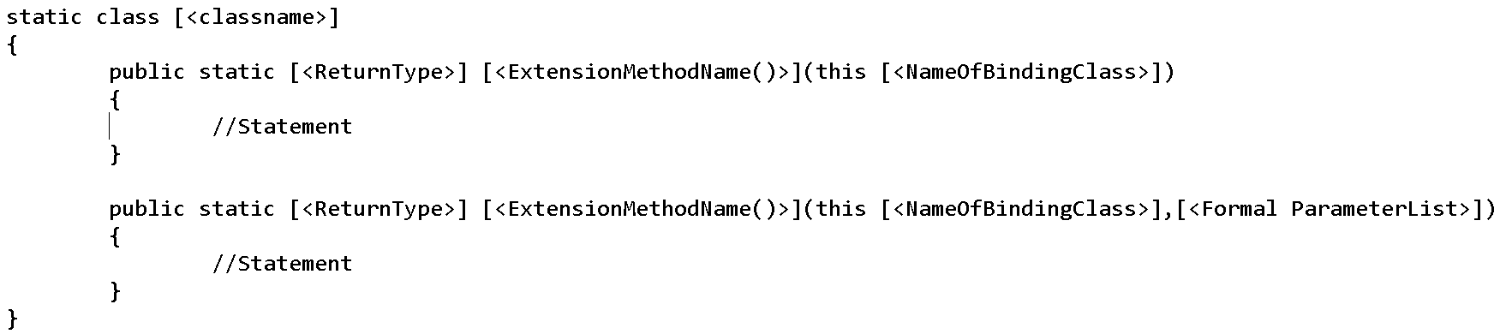

1. For binding the extension method to the class we need to use “**this**” keyword.
2. Extension methods are define as static but once they are bounded with any class or structure they turn into non-static method and hence we are able to call it using an instance variable of the binding class.

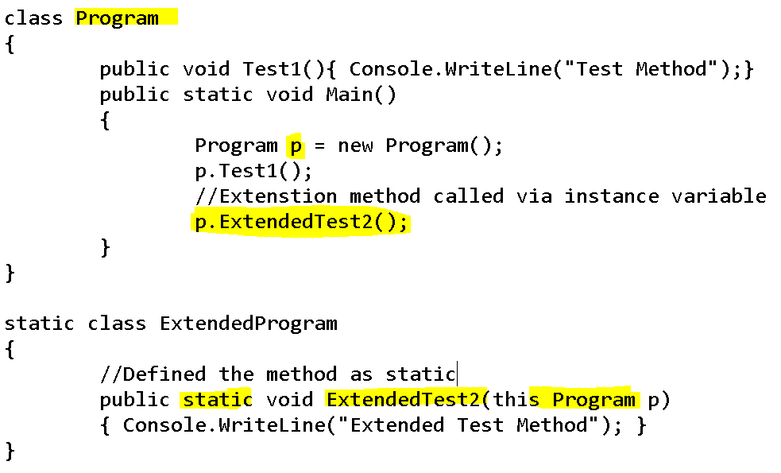

1. If an Extension method is defined with the same name and signature of an existing method of binding class, then extension method will not be called and the first preference always goes to the original method(Binding class method) only

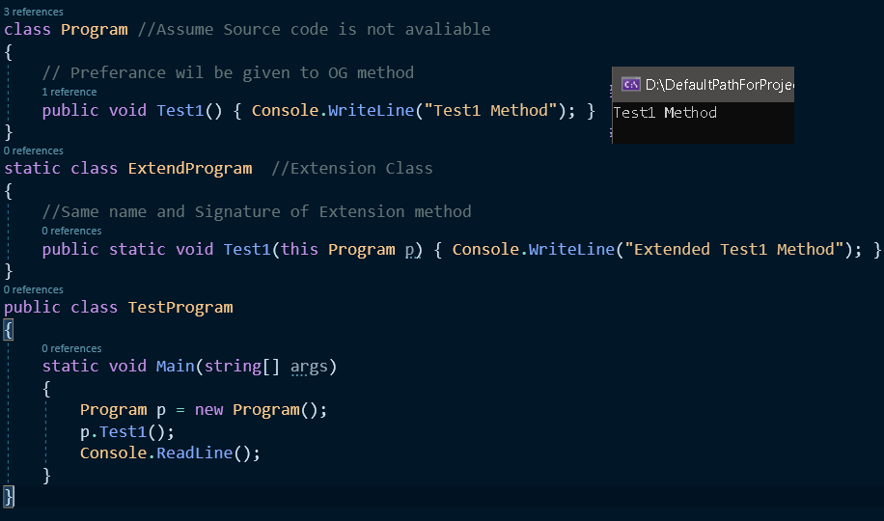

1. The first parameter of an extension method should be the name of the type (class or strut name) to which that method has to be bounded with and this parameter is not taken into consideration while calling the extension method via instance variable of binding class.
   1. If an extension method is defined with “n” parameters then while calling it we only need to pass “n-1” parameters only because the binding parameter is excluded.
2. An extension method should have one and only one binding parameter and it should be in the first place of the parameter list.

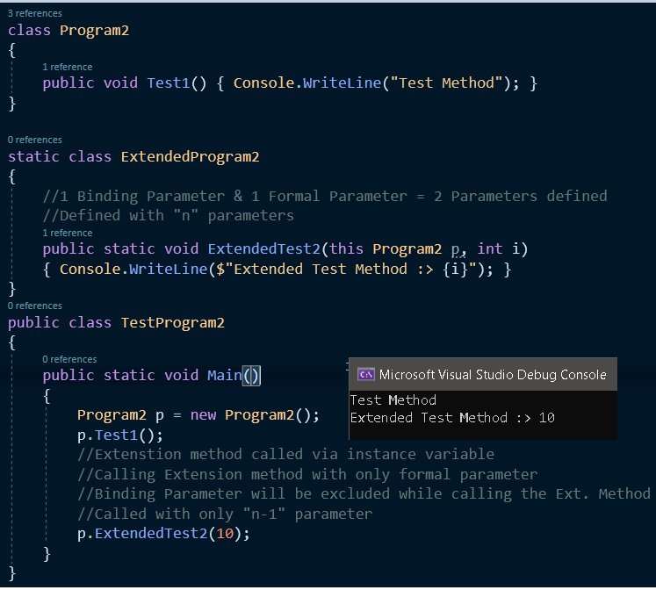

1. Extension method can be extend functionality to Structure

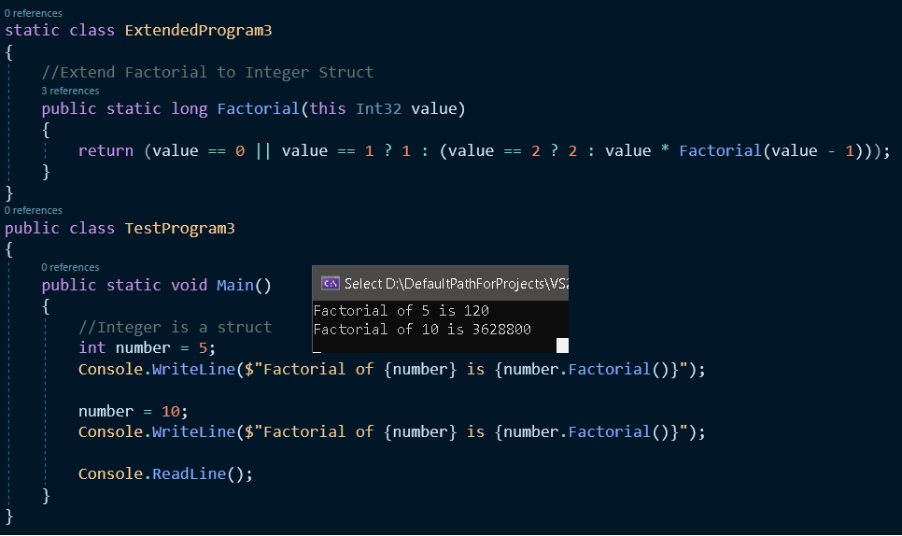

1. Extension method can extend functionality to sealed classes

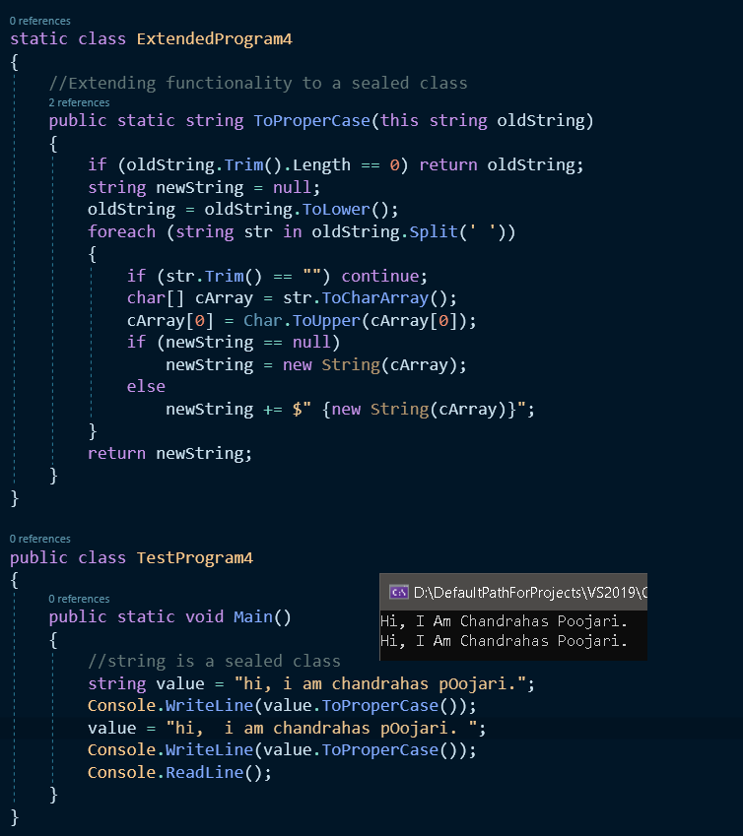

**Differences between String and StringBuilder**

1. Strings are immutable (unable to be changed) it creates new copies if any manipulation is conducted.
2. StringBuilder is mutable – It doesn’t creates new copies if any manipulation is conducted.
3. Heap memory representation of String & StringBuilder

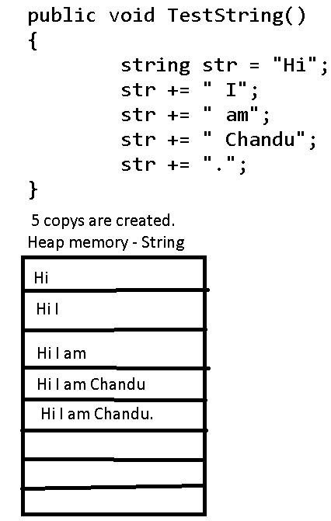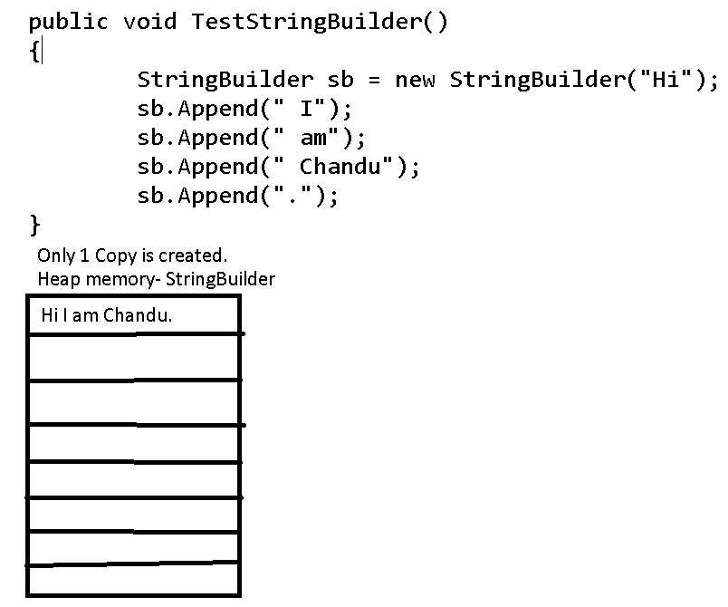

1. When to use
   1. String
      1. When there is no frequent changes in the initial string value assigned to it.
   2. StringBuilder
      1. When we are sure there will be frequent changes in the initial string value assigned to it.
2. String is slower than string builder & StringBuilder is slower than StringBuilder were initial capacity is provided.
3. String is under “System” namespace
4. StringBuilder is under “System.Text” namespace.
5. Performance wise it is better to use StringBuilder & if you provide StringBuilder with initial capacity then it enhances the performance more.
6. E.g. of Performance between string, string builder & string builder with initial capacity 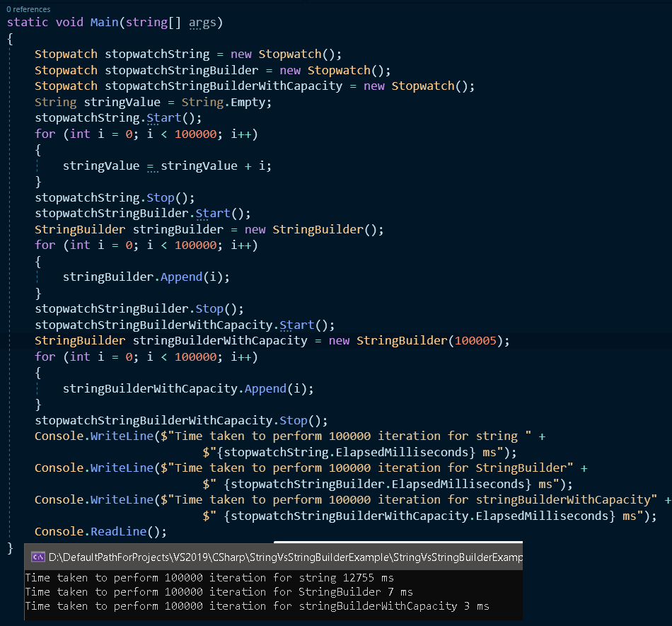

**Exceptions and Exception Handling**

1. Two types of Errors
   1. Compile Time Errors
   2. Runtime Errors- Cause abnormal termination of the program.
2. **Exception is a class responsible for abnormal termination of a program whenever runtime error occurs in a program.**
3. Compile Time Errors occurs due to syntax missing and other various reasons
4. Runtime Errors occurs
   1. Wrong implementation of logic –
   2. Wrong value to supplied to the code
   3. Missing Resources
   4. Many more ----
5. Few examples of Exception classes are listed below
   1. IndexOutOfBoundException
   2. DivideByZeroException
   3. OverflowException
   4. FormatException
   5. And many more..
6. Exception

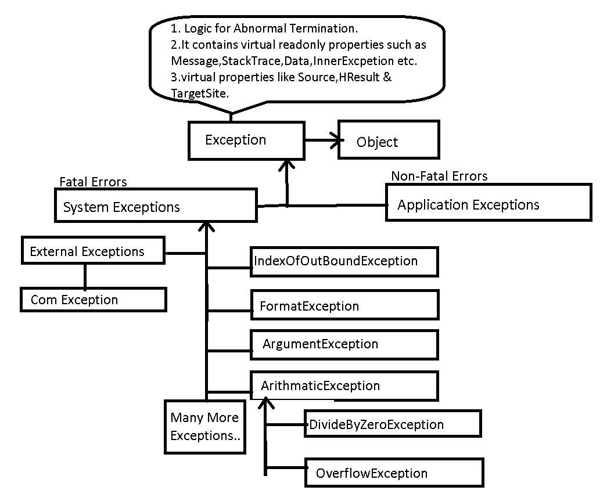

**Exception Handling**

1. Exception Handling is process of stopping abnormal termination of the program whenever a runtime error is occurring.
2. Advantages of Exception Handling
   1. Abnormal termination stops so that statement that are not related with errors can be executed.
   2. We can display user friendly error messages to end users so that we can describe about the error.
   3. We can perform corrective action to resolve the problems that may come into picture due to the error.
3. How to handle exception

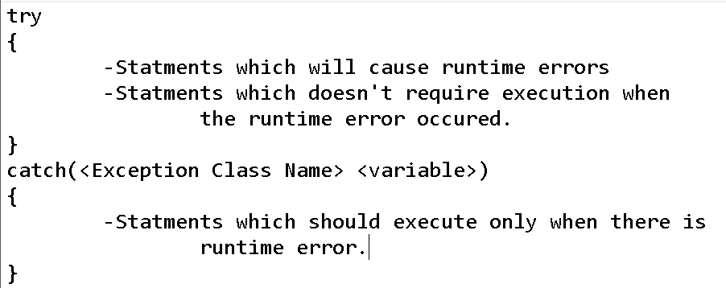

1. If any statement of try causes an error, from that line of code the control jumps to catch block searching for matching catch block
   1. If there is matching catch block that can handle the exception, abnormal termination stops it will execute the code in the catch block and then to first line after the catch block.
   2. If there is no matching catch block for the error then abnormal termination will occur.
2. Finally block –
   1. Mandatory execution for code which is inside the finally block.
   2. Finally block executes even if there is abnormal termination of program.

|  |  |  |
| --- | --- | --- |
| Try Catch Finally | Try Finally | Try Catch |
|  |  |  |

1. Try Catch Finally –Exception are handled and mandatory execution of code inside finally block.
2. Try Catch – Exceptions are handled.
3. Try Finally – Exception are not handled, abnormal termination is guaranteed but mandatory execution of code inside finally block.

**Exceptions – Applications Exceptions**

1. System exceptions are thrown by CLR on bases of predefined conditions i.e. overflow, format and divide by zero etc.
2. Application exceptions are thrown & created by programmer on the bases of business logic.
3. How to create & throw Application Exception

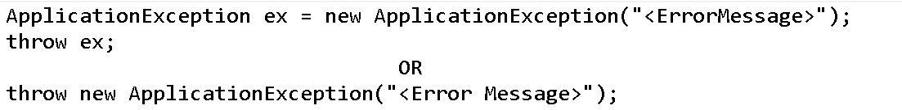

1. Application Exception E.g.

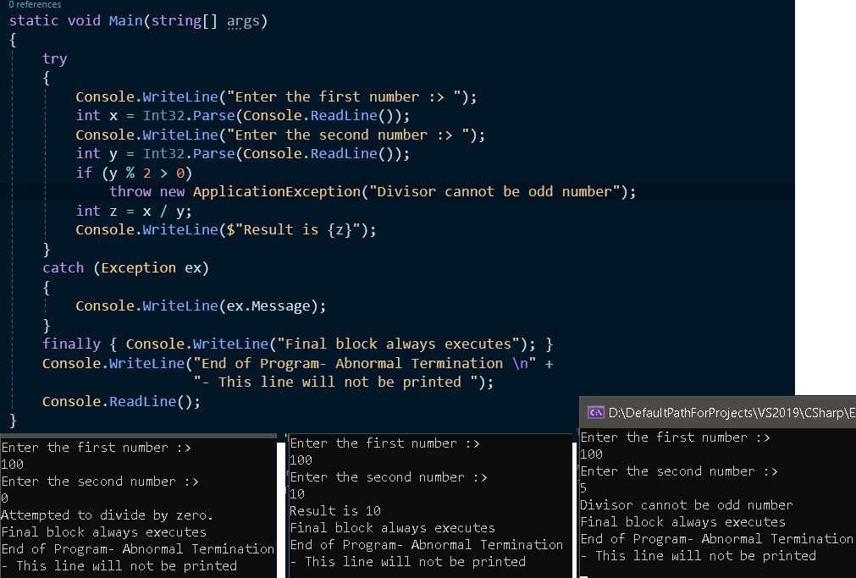

1. **Defining our own Application Exception Class :**
   1. Inherit the class from ApplicationException
   2. Override virtual read-only properties such as Message, Data, Source, StackTrace etc.

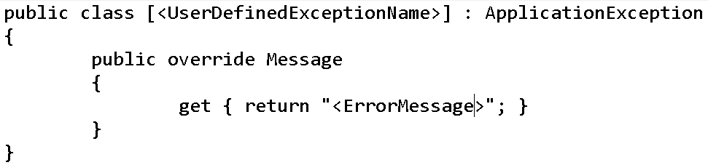

1. Application Exception class E.g.

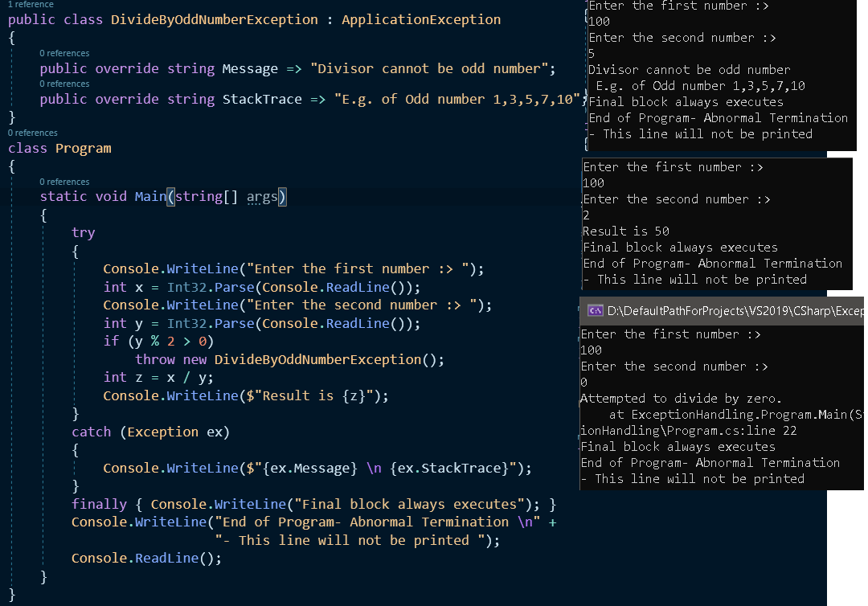

**Multi-Threading**

1. **Multi-Tasking** – Programs are capable for running more than one application (Task) at a time. Operating Systems are multi-tasking systems. To execute application, it uses processes internally to run this applications.
2. **Process** – is a part of the Operating System responsible for executing the program.
   1. Background Process – Services e.g. Database Engine, Required Program of OS.
3. Every Application by default contains one thread to execute the program and that is known as **Main Thread**. So every program is by default single threaded model.
4. **Single Threaded Model** – All the logic is run by one thread and it executes the logic one after the other. Drawback of Single Threaded Model
   1. Actions are completed one after the other. If one action is delayed than below/next action also needs to wait till the action above/before it is completed.
5. **Multi-Threading -** Process having multiple threads and each thread is executing simultaneously.

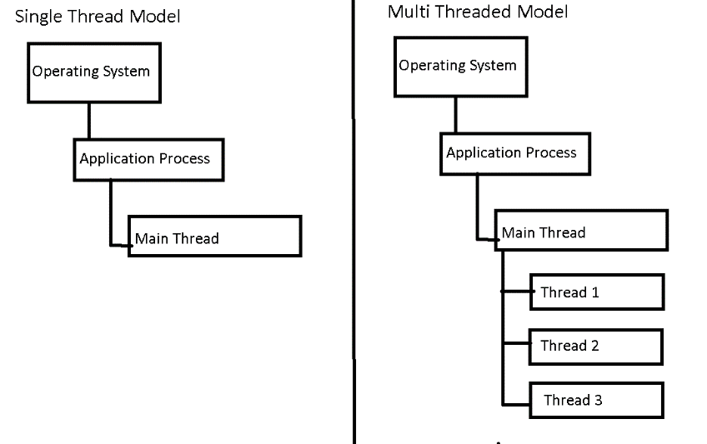

1. Multi-Threading works based on **Time-Sharing concept**.
   1. All the threads that created under the process will be given equal important to execute.

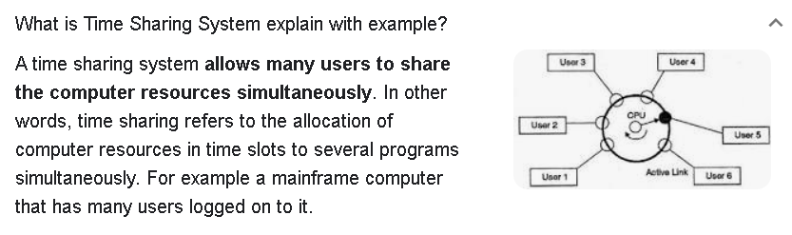

1. Advantages of Multi-Threading
   1. Simultaneous execution of logic hence time will be saved.
   2. Maximum utilization of CPU Resources.
2. How to implement Multi-Threading



1. Multi-Threading E.g.

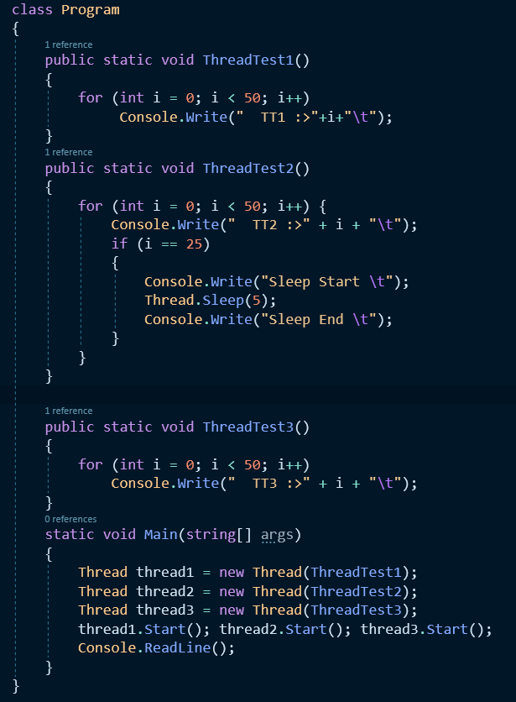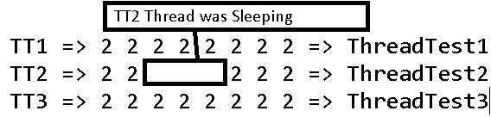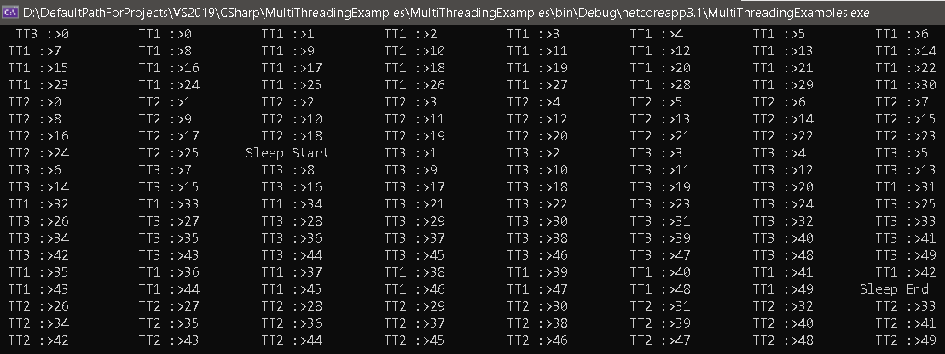

1. Thread Constructors take 4 overload but we will be discussing only below two
   1. ThreadStart -
      1. Takes no input parameter and return type is void

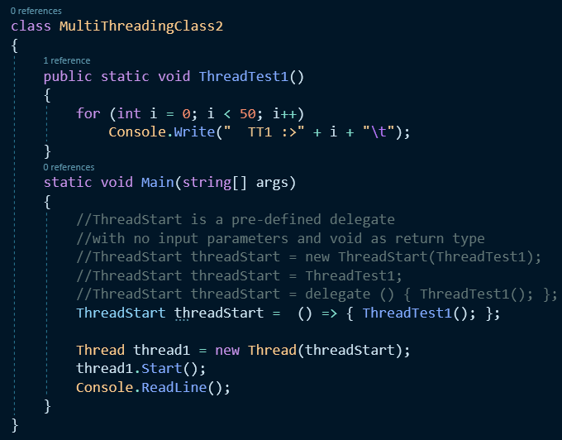

* 1. ParameterizedThreadStart –
     1. Takes 1 input parameter as **object** and return type is void.
     2. In ParameterizedThreadStart, we need to pass the parameter via **Start** method.
     3. The method should declare the input parameter as **object.**
     4. The ParameterizedThreadStart’s are not type safe.

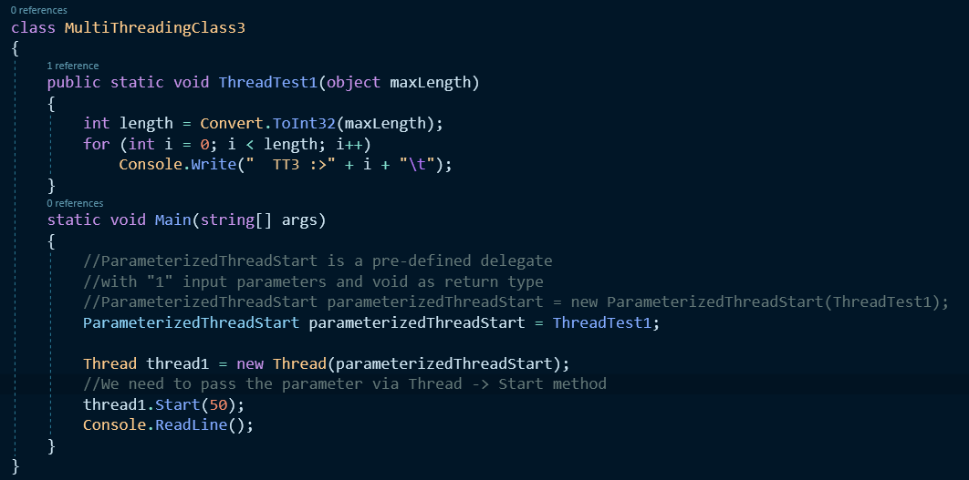

**Thread Join –**

* Join – Main Thread waits until all the child thread finish’s execution and then exists.
* Join([<TimePeriod>]) – Main Thread will wait until the specify Time period and then it will exit even if the child thread have not finished the execution.
* Thread Join Example

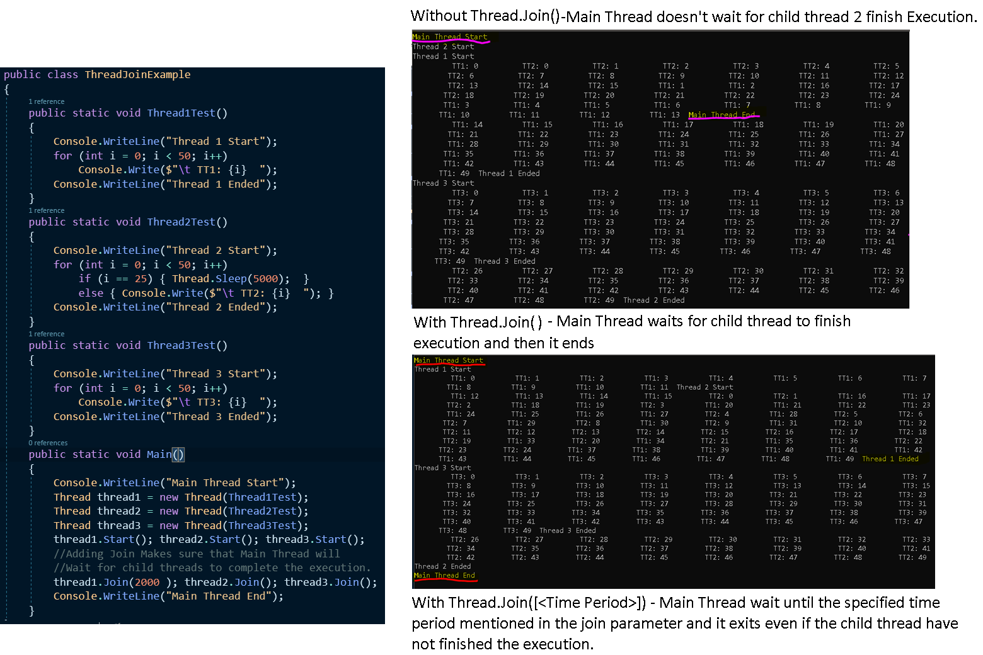

**Locking resources –**

* To overcome the problem of multiple threads accessing the same resources & getting un-expected results we need to add **lock** on that resource.
* So that at a time only one thread is accessing the resource.
* How to lock the resources
  + - * 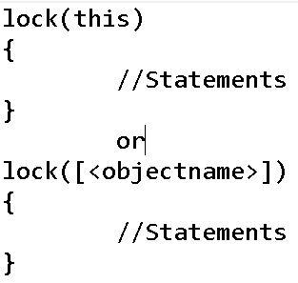
* Thread Locking Example

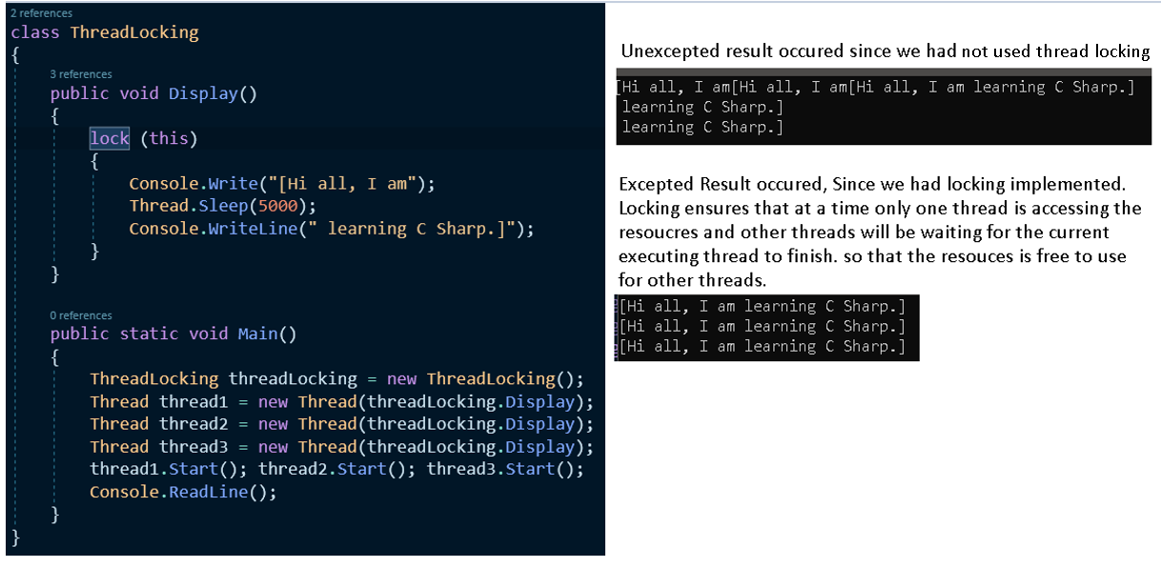

**Thread Priority**

1. Thread Priority indicates how frequently the thread will gains CPU resources.
2. Thread Priority
   1. Highest – 4
   2. Above Normal – 3
   3. Normal – 2 – Default.
   4. Below Normal – 1
   5. Lowest – 0
3. By default all the thread will have Normal Priority
4. Programmer can change thread priority.
5. Operating system doesn’t assign priority of threads.
6. Thread Priority Example.

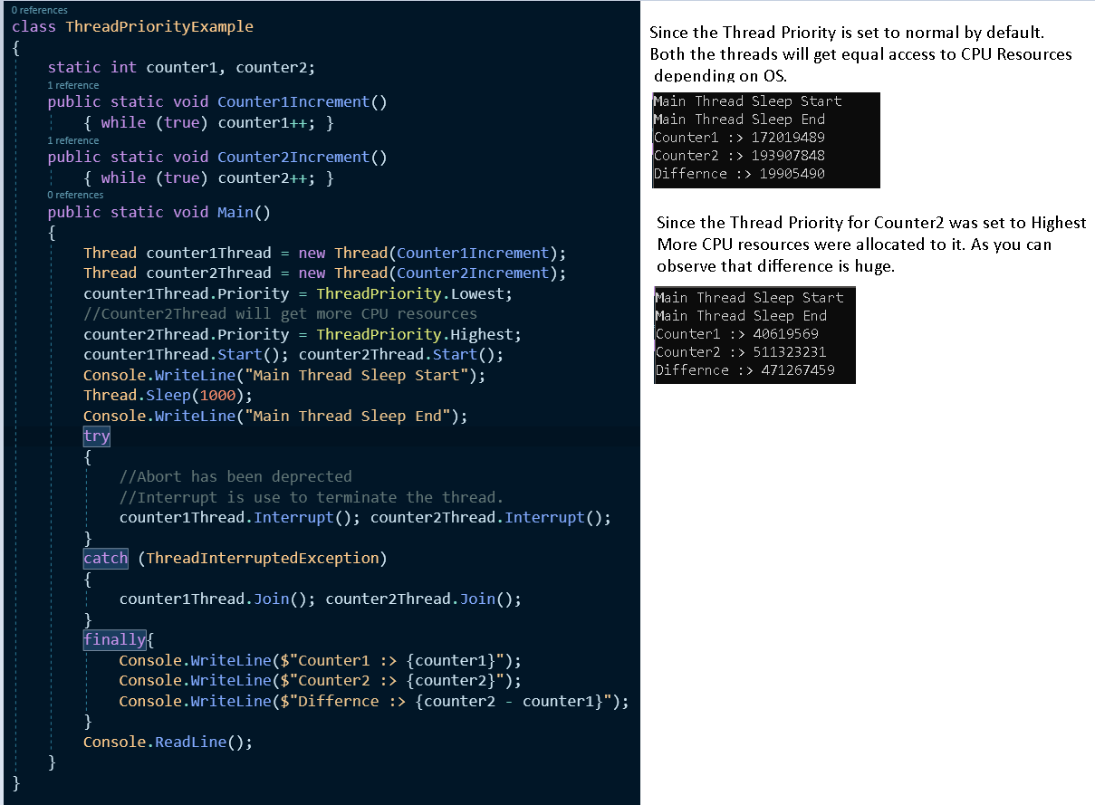

1. Performance wise – Multi-Threaded Model is better than Single Threaded Model. In Multi-Threaded Model, Resources are shared between the threads created under main thread.

**Collections**

1. Collections are dynamic arrays.
2. Collection overcome the below issue Arrays have
   1. Arrays cannot be resized i.e. increasing the size after declaration.
   2. We cannot add items in the middle of the array.
   3. We cannot delete/remove items from the middle of the array.
3. Collection have feature known as Auto-Resizing, it has capability to add, delete items in the middle of the collections.
4. Collections are defined under System.Collection(Non-Generic)
   1. Stack, Heap, LinkedList, SortedList, HashTable, ArrayList…
5. Difference between Array & ArrayList

|  |  |
| --- | --- |
| Array | ArrayList |
| Fixed Length | Variable Length |
| Not Possible to insert items in the middle | Possible to insert items in the middle |
| Not Possible to remove items in the middle | Possible to remove items in the middle |

1. Auto-Resizing – collections increases in size whenever a new item is added but only when it doesn’t have the capacity to hold it.
2. Example of Array List- Auto-Resizing, Add, Insert & Remove

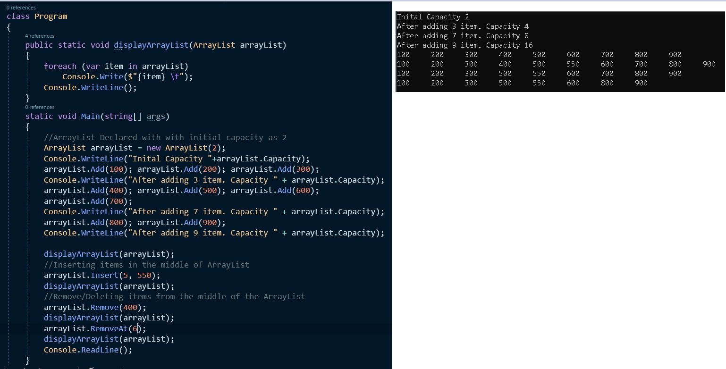

1. Difference between Hashtable & (Array & ArrayList)
   1. Array & Array List Key/Value combination where keys are pre-defined i.e. index
      1. It is hard to remember the index value for retrieving particular data.

Array[0], Array[1] …. Array[n] – N is integer value.

* 1. Hashtable stores the value and key is user-defined.

Hashtable[“Chandrahas”], Hashtable[“PPP”] etc..

1. In Hashtable, keys can be double, integer or strings
2. How to define and add data in hashtable & also How to access value from hashtable

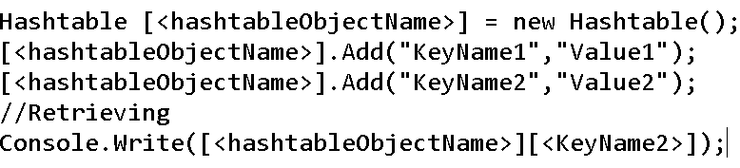

1. Hashtable’s internally generates hash code for key values. It fetches data based on the hashcode value of the key. Due to this reason Hashtable’s are more efficient as compare to ArrayList.
2. Example of Hashtable

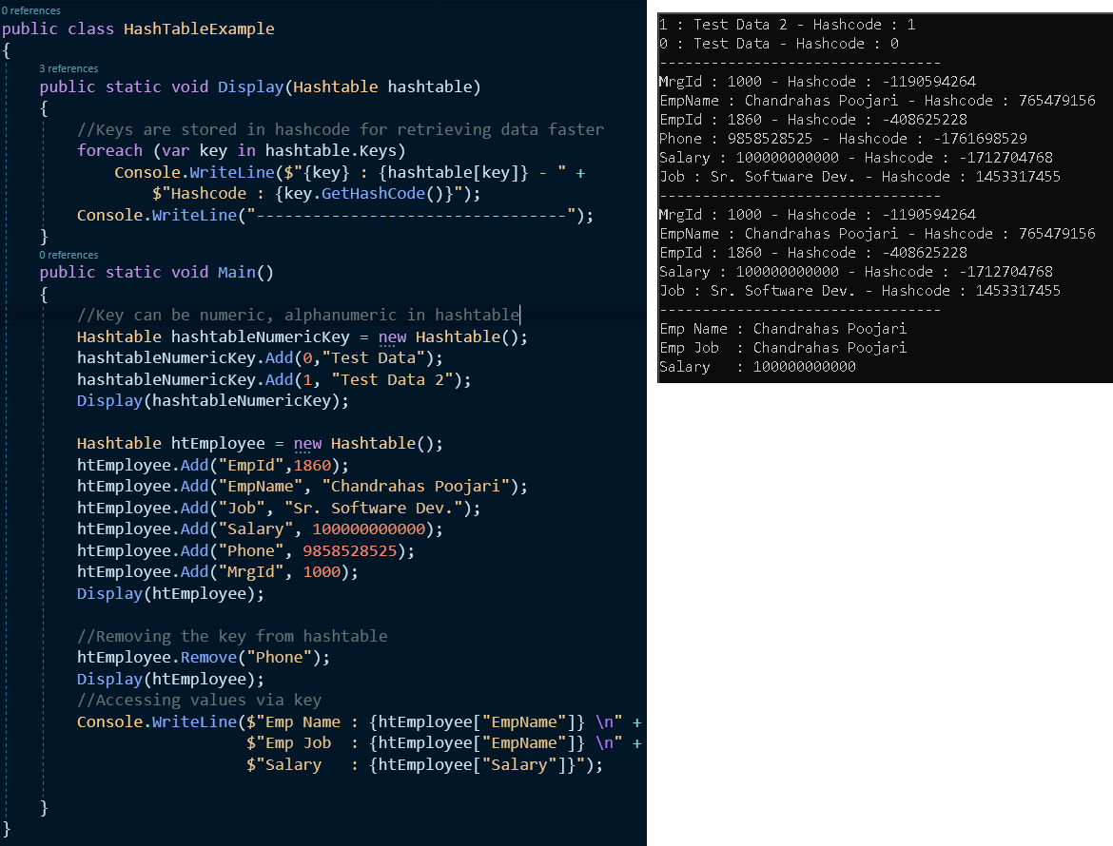

**Collections - Generic**

1. Non-Generic Collections are not type safe.
2. Generic collections are combination of
   1. Arrays – Type Safe but doesn’t have Fixed Length.
   2. Collections – Auto Resizing but not type safe.
   3. In C# 2.0, Generic Collections were introduced under “System.Collection.Generic“ to overcome the issues such as type safe collection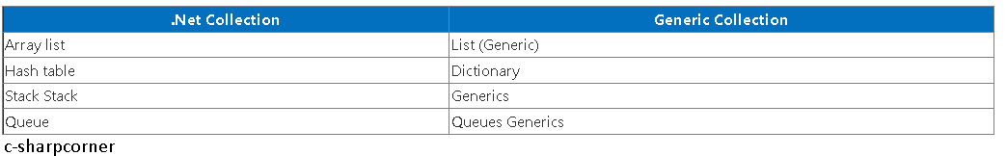
3. Advantages of Generic Collection.
   1. Type Safe
   2. Auto-Resize
4. How to define List<T>

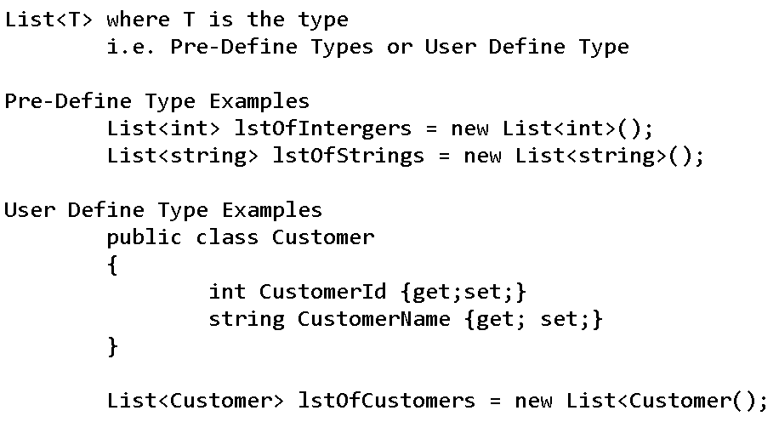

1. Example of List<T>

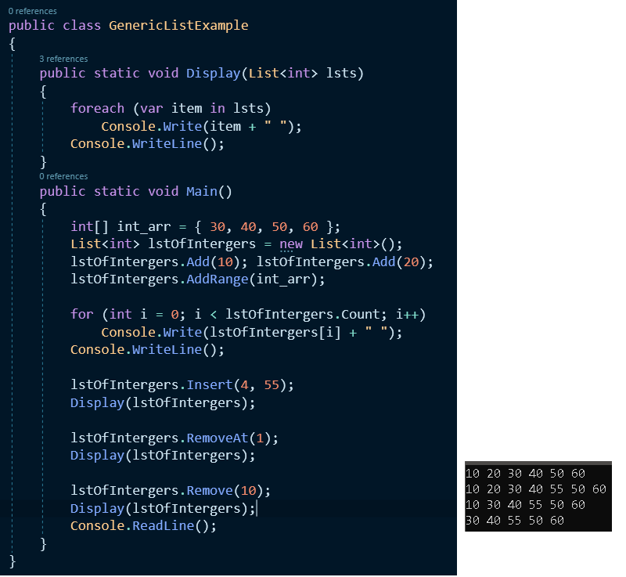

**Generics**

1. Generics – C# 2.0
   1. We can create strongly Type entities.
   2. Improves performance, since we can avoid boxing and unboxing of the object.
   3. Less Coding
2. Boxing & Unboxing – performance issues are created if not used efficiently.
   1. Boxing – is an implicit conversion of value type to the object type. Boxing a value type allocates an object instance on the heap memory and copies the value into the new object.
   2. Unboxing - is an explicit conversion of object type to value type.

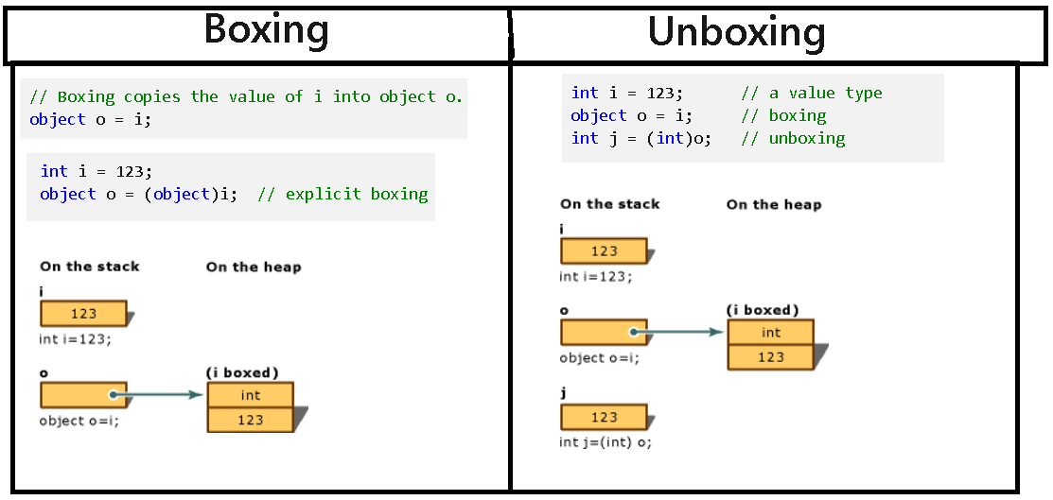

1. How to define Generic Method

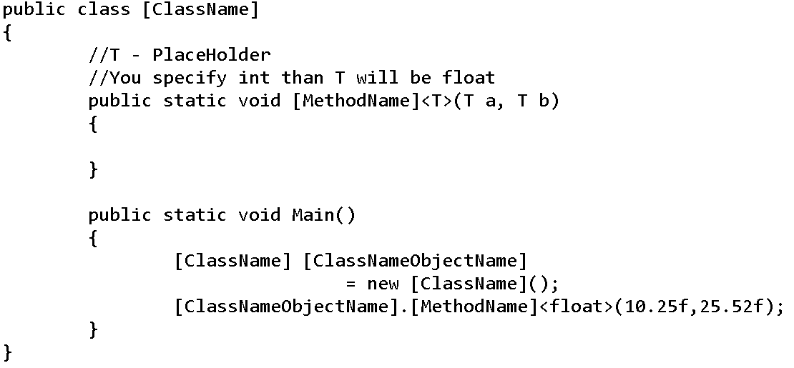

1. Example of Non Generic & Generic Code

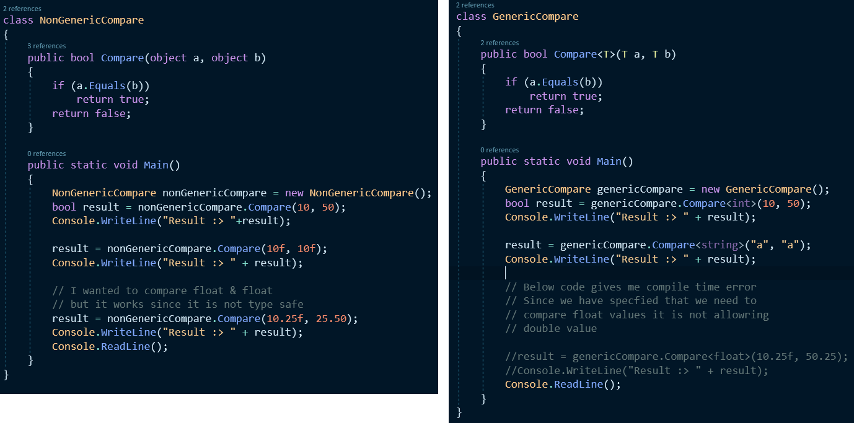

1. Dynamic Vs var

|  |  |
| --- | --- |
| **Var** | **Dynamic** |
| It was introduced in C# 3.0 | It was introduced in C# 4.0 |
| The variable are declared using “var” keyword are statically typed. | The variable are declared using “dynamic”  Keyword are dynamically typed. |
| The type of the variable is decided at compile time. | The type of the variable is decided at run time. |
| If the variables does not initialized it throws error. | If the variables does not initialized it will not throw an error. |
| It cannot be used for Properties or Returning values from the method. It can be used only as local variable in the method. | It can be used for properties or returning values from the method. |

1. Example of dynamic, Generic Class & Method

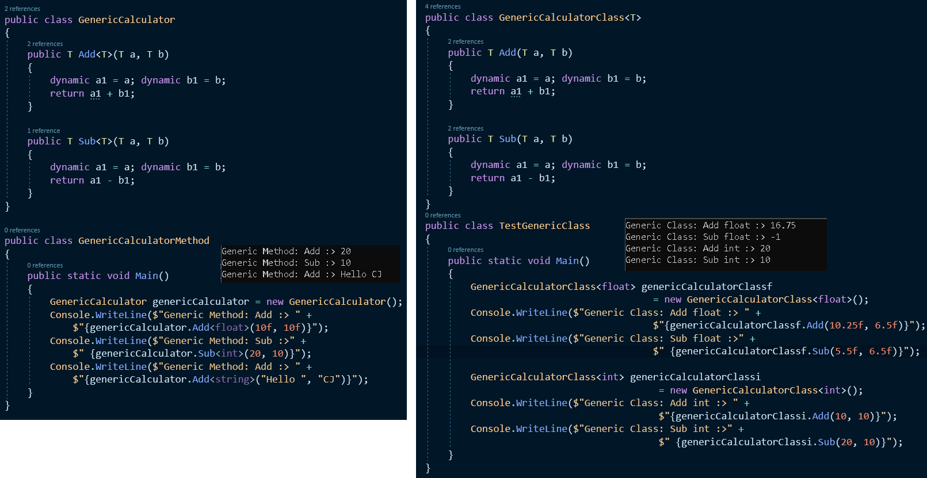

1. In case of generic collections the type of values, we want to store under the collections need not to be pre-defined typed only i.e. float, int, double, string etc. but it can be also some user defined type also.
2. Example of User-Defined Type for Generic collections

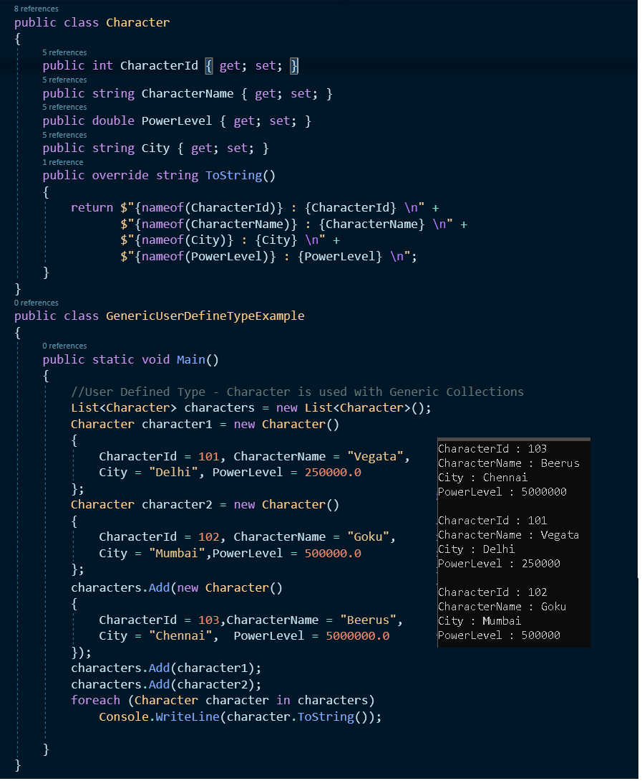

Reference

* <https://www.geeksforgeeks.org/difference-between-var-and-dynamic-in-c-sharp/>
* MS docs

**Generics – Constraints**

1. Constraints are used in Generic to restrict the types that can be substituted for type parameters
2. When constraints are applied on the generic method or class, the substituted type parameter needs to comply with the constraint defined. If it doesn’t follow then compile time error occurs.
3. How to define Constraints

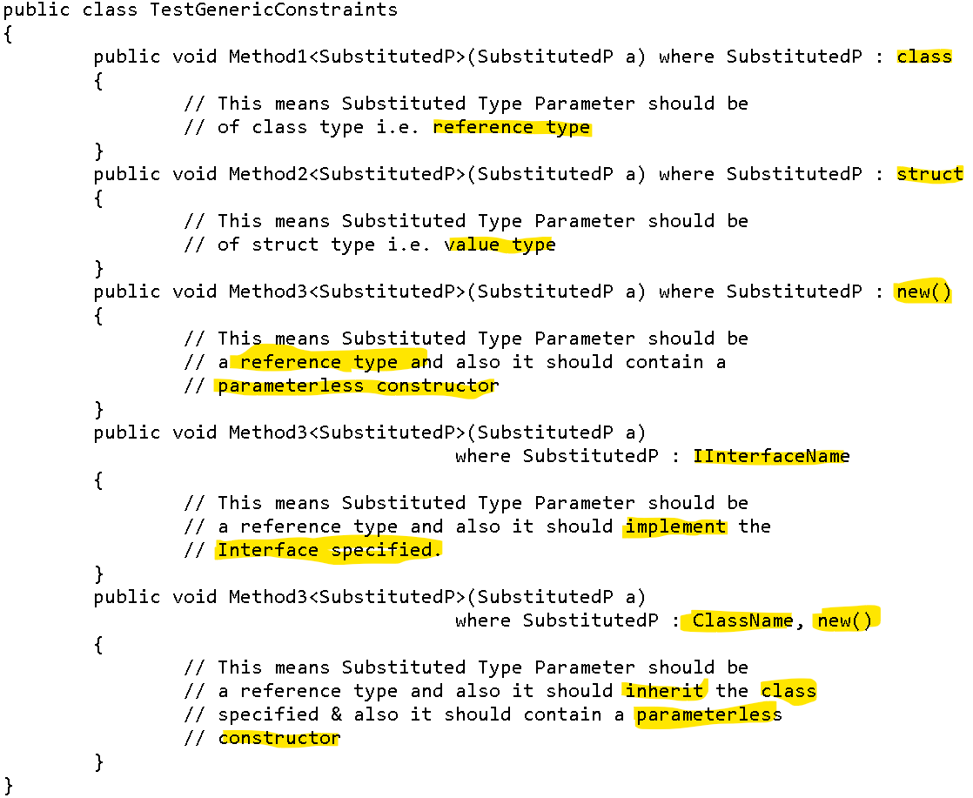

1. Example of Constraints…

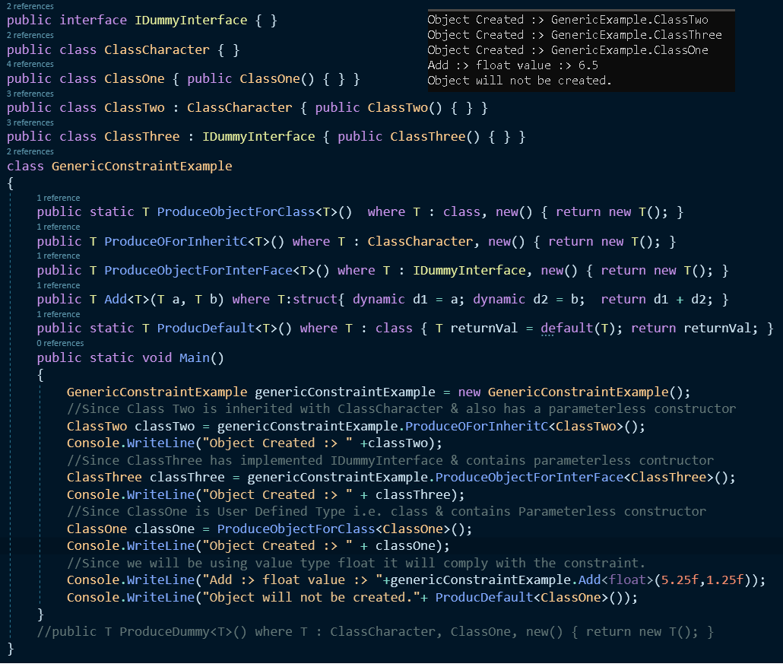

1. We can have only one primary constraint as a Base Class. i.e. to say the below code is illegal.

Since multiple inheritance is not allowed in C#.

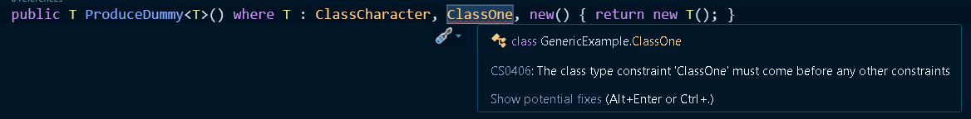

1. We can use default keyword for class & struct type
   1. Class type will provide null
   2. Struct type will provide 0

References

* <https://www.youtube.com/watch?v=oitvN9YC_PU>
* <https://www.youtube.com/watch?v=PF_LPi_9lqo>
* <https://www.youtube.com/watch?v=aGvmqtfFjOw>
* <https://www.c-sharpcorner.com/UploadFile/ashish_2008/constraints-in-generics/>

**Generic Collections – IComparable<T> & IComparer<T>**

1. For Sorting a primitive datatype such as int, float, double etc., we can directly use “**List.Sort()**”.

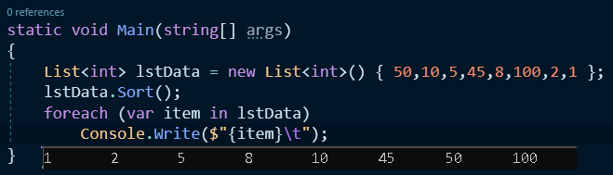

1. For Sorting, user defined data types “**Sort()**” will give us a run time error if programmer have not implemented below interfaces
   1. IComparable<T> - When the class is mutable(can be changed)
      1. We use IComparable<T>, when we have the source code of the class to which it will be implemented.
      2. It implements CompareTo(T name) method where T is class which needs to be compared with the current class ”this”.
   2. IComparer<T> - - When the class is immutable(cannot be changed)
      1. We use IComparer<T>, when we don’t have the source code of the class to which it will be implemented.
      2. It implements Compare(T a, T b) method where both the classes will be compared.
   3. For both return type is integer

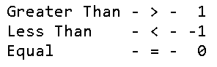

1. Example for IComparable & IComparer.
   1. Part 1 – Implementation of IComparable & IComparer.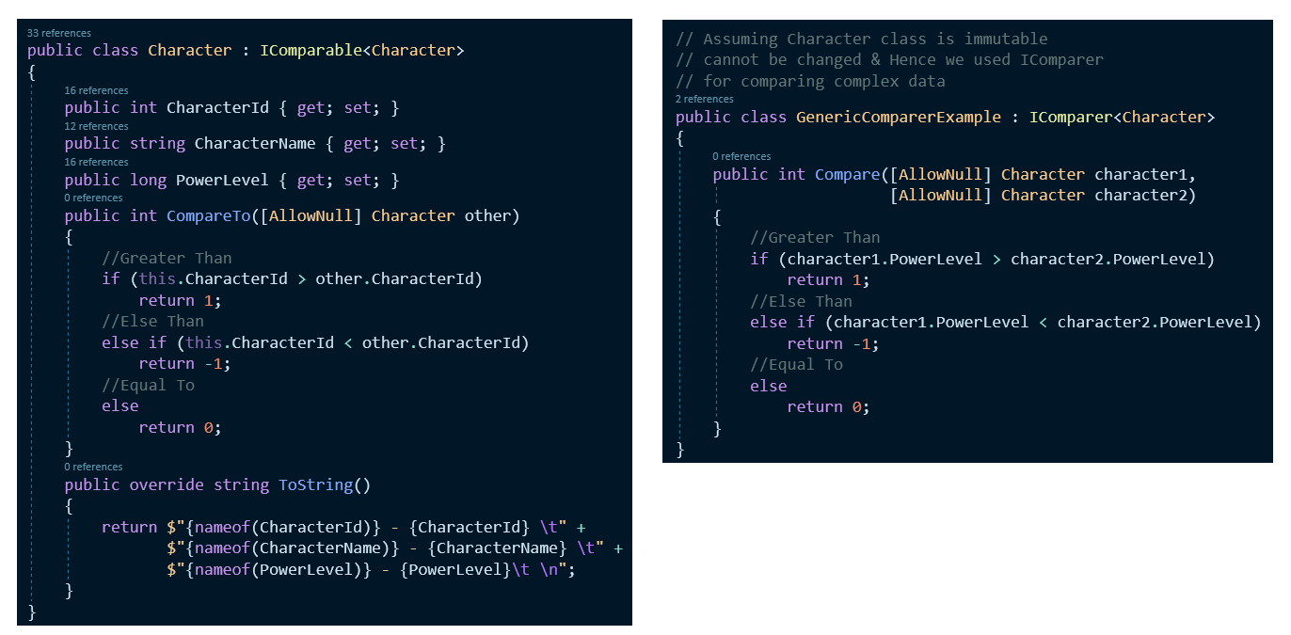
   2. Part 2 – Calling Sort on List Object.

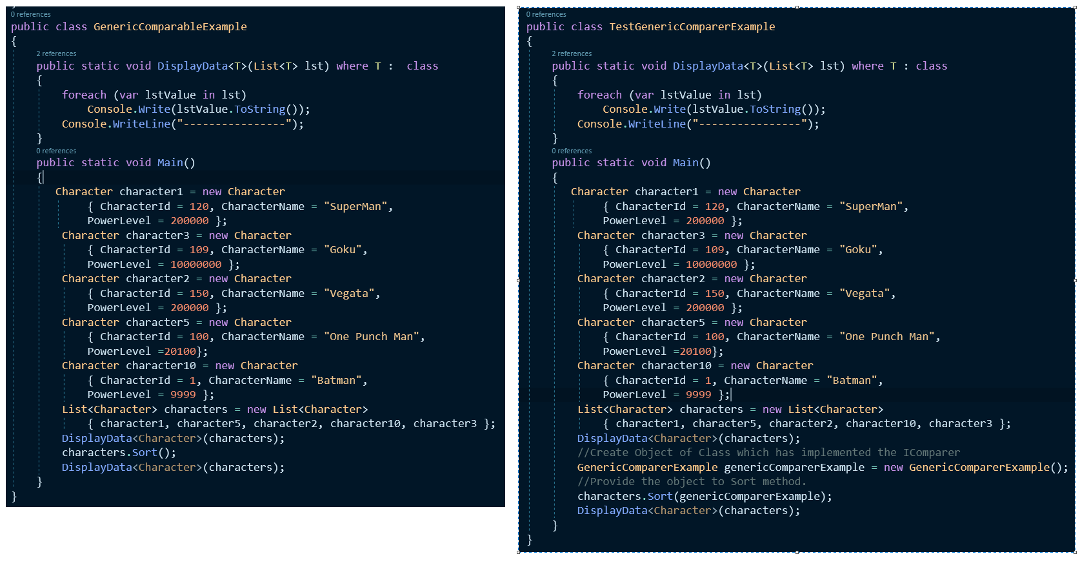

* 1. Part 3 Output

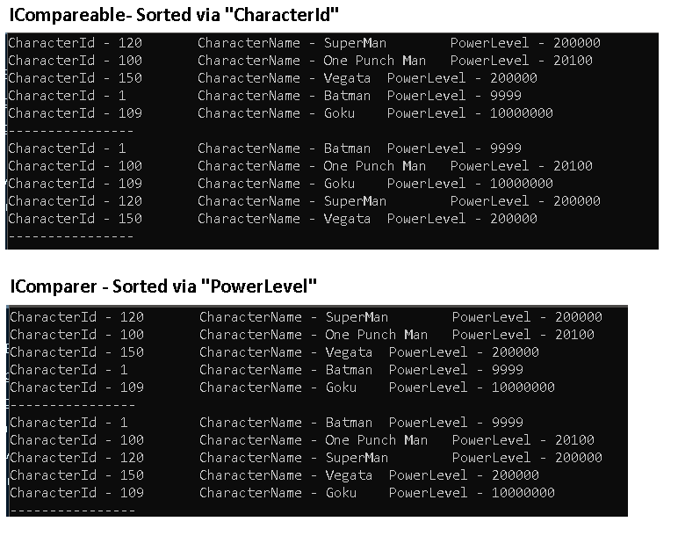

**Collections – IEnumerable or IEnumerable<T>**

1. IEnumerable is an interface that is implemented by all the collection classes and because they implement this IEnumerable interface every collection class contains a method called as GetEnumerator and because of that method we can use foreach loop on that collection.

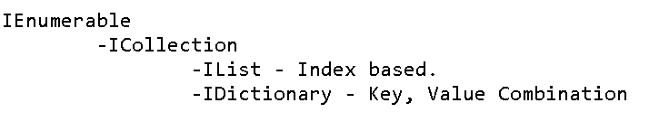

1. If we need to define our own class to behave like collection then we need to implement IEnumerable interface and write the implement GetEnumerator method.
2. How to make you class behave like collections

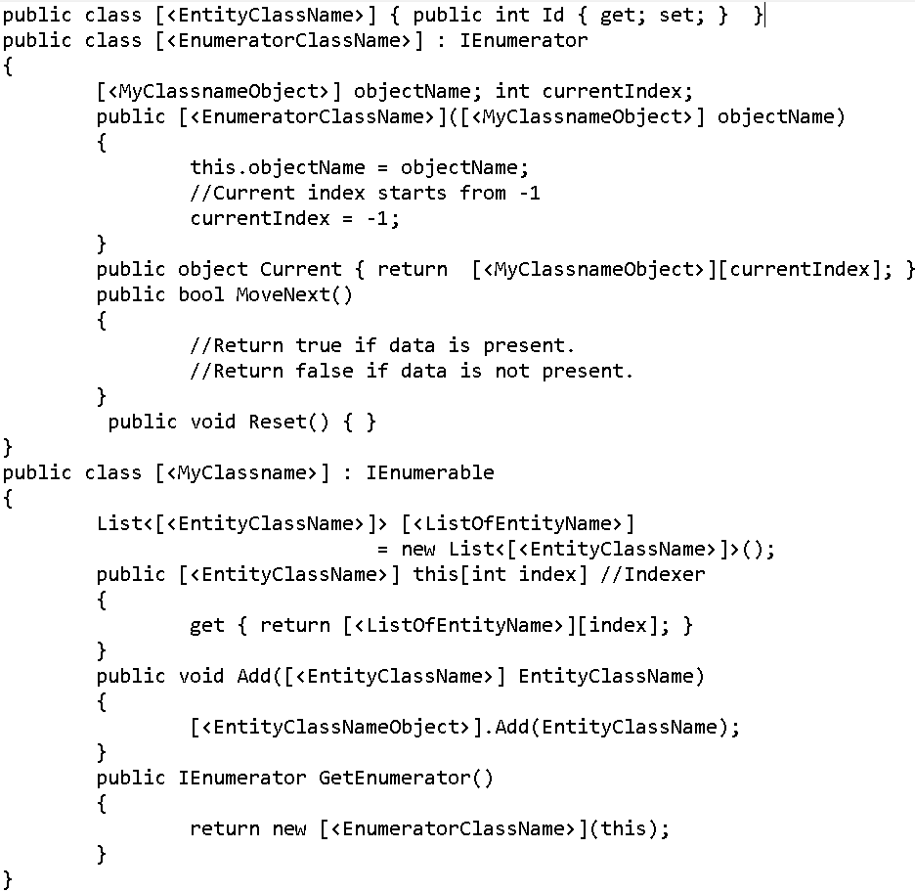

1. Example of IEnumerable

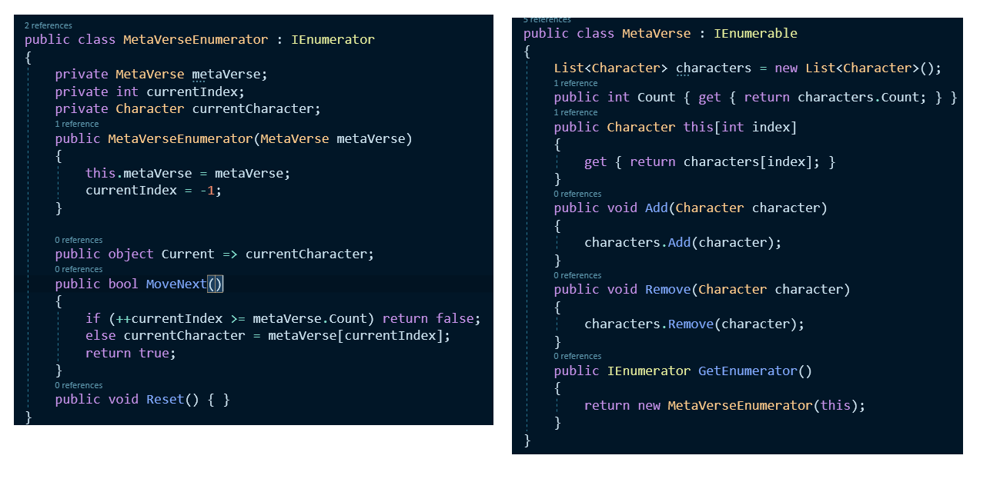

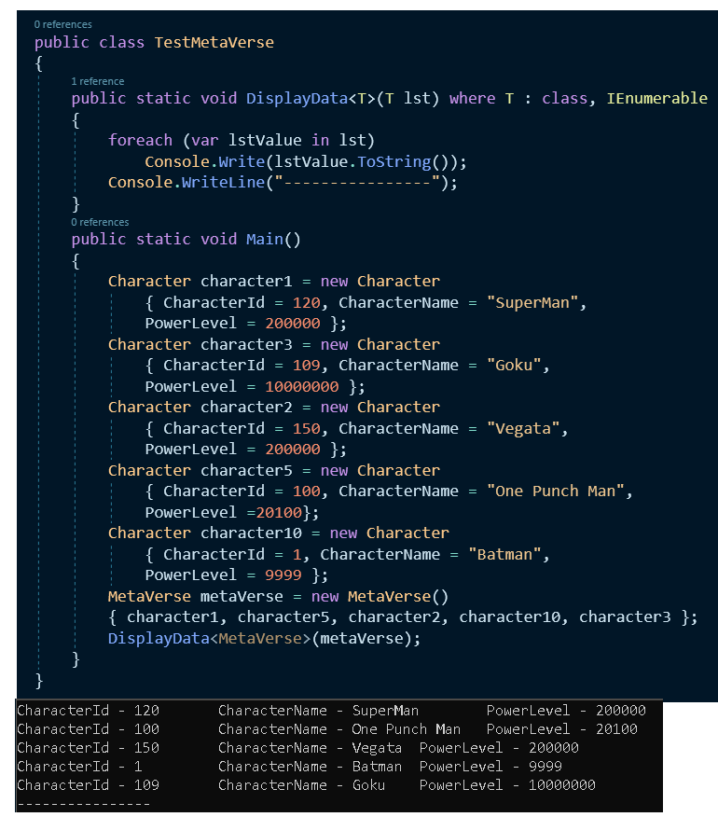

**LINQ – Language integrated Query**

1. Using Linq, we can write queries on a wide variety of data sources
   1. Arrays
   2. Collections
   3. Database Tables
   4. Datasets
   5. Xml Data
2. Syntax SQL Vs Linq

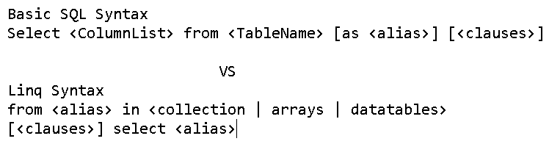

1. Example of Linq

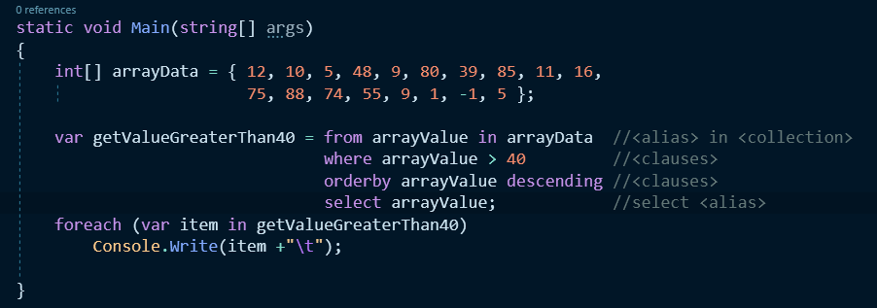

1. Linq
   1. Linq to Objects – Arrays, Collections etc.
   2. Linq to Database– DataTables & Relational Database Tables
      1. Linq to ADO.NET
      2. Linq to SQL – SQL Servers
      3. Linq to Entities – SQL Servers, Oracles & SqlLite etc.
   3. Linq to Xml – Xml files
2. Linq to SQL - It is a query language that is introduced in .Net 3.5. Framework for working with relational database i.e. SQL Server.
3. Linq to SQL is not only about querying the data but also allows us to perform CRUD operations. CRUD stands for
   1. C – Create (insert)
   2. R - Read (select)
   3. U- Update
   4. D – Delete

Note: we can also call store procedure by using Linq to SQL.

1. SQL => SQL Server Vs LINQ => SQL Server

|  |  |
| --- | --- |
| **SQL => SQL Server** | **LINQ => SQL Server** |
| Runtime Syntax checking of SQL statements. i.e. extra load on server if syntax is not correct. | Compile-Time Syntax checking is performed by C# compiler itself using query engine under .NET framework. |
| Not Type Safe. | Type Safe. |
| No Intellisense Support. | Intellisense support is available. |
| Debugging of SQL statement is not possible | Debbuging of Linq SQL is possible. |
| Code is combination of Object Oriented and Relational. | Code is purely Object Oriented Code. |

1. Remember

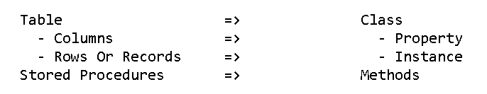

1. Sql Vs Linq Statements



1. Clauses in SQL Vs Clauses in Linq.

|  |  |
| --- | --- |
| **Clauses in SQL** | **Clauses in Linq.** |
| Where | Where |
| Group By | Group By |
| Order By | Order by |
| Having | Where clause if used after Group Clause then it acts like Having Clauses |

1. Order By – Default ordering is ascending.

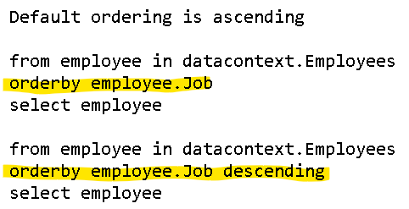

1. Where Clause

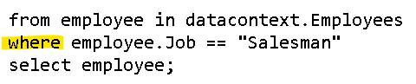

1. Group By Clause –
   1. Data is grouped into two part key part and result part
      1. Group Key – The key on which grouping was done
      2. Group Result – where aggregate functions will be called i.e. Count, Avg, Max, Min, Sum

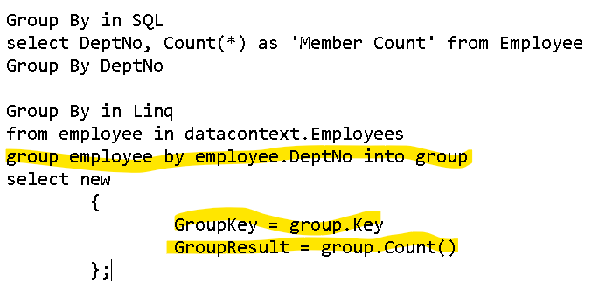

1. Group by Clause with Having clause.
   1. Linq does have “**Having**” clause, programmer need use “where” clause to achieve the result.
   2. **Where** clause used **before** **Group** clause will **behave** like normal “**where**” clause.
   3. **Where** clause used **after** **Group** clause will **behave** like “**having**” clause.

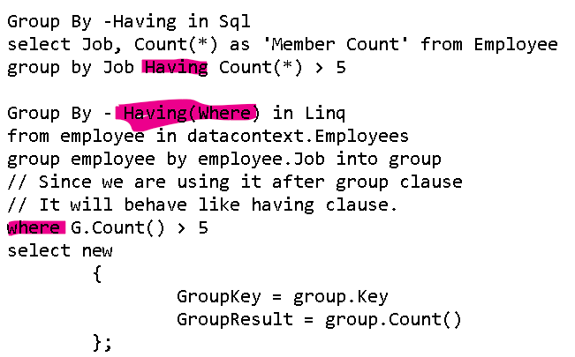

1. Multiple Clauses

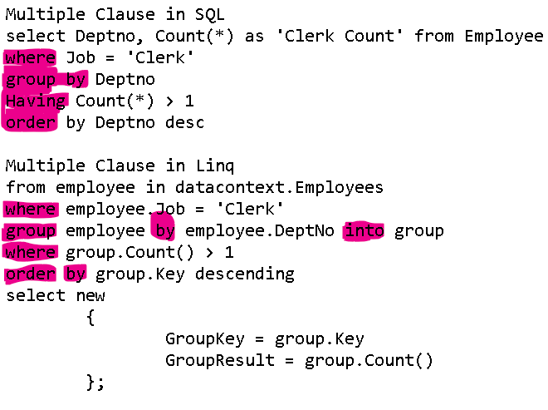

1. In Linq – when multiple clauses are used. Clause needs to follow the Sequence as shown below
   * 1. Where clause – first where clause will execute sends the data to group by clause
     2. Group by clause – will group the data and will send the data to “having” clause
     3. Having (where) clause – will apply filters on the grouped data and remove unwanted data.
     4. Order by clause – finally order by clause will arrange the data and display the data.

Repositories for Code :

* [Github - ChandrahasJ](https://github.com/chandrahasJ/Chandu816_2021_2022_V2/tree/main/Interview2.0/CSharpRepo)

Reference & Thanks to:

* [Naresh IT YouTube Channel – C# Playlist](https://www.youtube.com/playlist?list=PLVlQHNRLflP-jc5Fbhfdhzv52AWYq836j)
* Microsoft Documentation.
* Jamie Kings YouTube Channel.
* Websites - C-Sharp Corner & Many more

**Thank you**